​
​
UNITED STATES
SECURITIES AND EXCHANGE COMMISSION
Washington, D.C. 20549
​
​
FORM 8-K
​
​
CURRENT REPORT
​
Pursuant to Section 13 or 15(d) of The Securities Exchange Act of 1934
​
Date of Report (Date of earliest event reported): August 3, 2026 (August 3, 2026)
​
Matson, Inc.
(Exact Name of Registrant as Specified in its Charter)
_____________________
​

Hawaii | ​ ​ | 001-34187 | ​ ​ | 99-0032630
(State or Other Jurisdiction of  Incorporation) | ​ | (Commission File Number) | ​ | (I.R.S. Employer Identification  No.)
​

 |  | ​
1411 Sand Island Parkway | ​ ​ | ​
Honolulu, Hawaii | ​ | 96819
(Address of principal executive offices) | ​ | (zip code)
​
Registrant’s telephone number, including area code: (808) 848-1211
(Former Name or former address, if changed since last report)
_____________________
​
Check the appropriate box below if the Form 8-K filing is intended to simultaneously satisfy the filing obligation of the registrant under any of the following provisions:
​
☐ | Written communications pursuant to Rule 425 under the Securities Act (17 CFR 230.425)
​
☐ | Soliciting material pursuant to Rule 14a-12 under the Exchange Act (17 CFR 240.14a-12)
​
☐ | Pre-commencement communications pursuant to Rule 14d-2(b) under the Exchange Act (17 CFR 240.14d-2(b))
​
☐ | Pre-commencement communications pursuant to Rule 13e-4(c) under the Exchange Act (17 CFR 240.13e-4(c))
​
Securities registered pursuant to Section 12(b) of the Act:
​

Title of each class | Trading Symbol(s) | Name of each exchange on which registered
Common Stock, without par value | MATX | New York Stock Exchange
​
Indicate by check mark whether the registrant is an emerging growth company as defined in Rule 405 of the Securities Act of 1933 (§230.405 of this chapter) or Rule 12b-2 of the Securities Exchange Act of 1934 (§240.12b-2 of this chapter).
Emerging growth company ☐
If an emerging growth company, indicate by check mark if the registrant has elected not to use the extended transition period for complying with any new or revised financial accounting standards provided pursuant to Section 13(a) of the Exchange Act. ☐
​
​
​
Item 2.02.Results of Operations and Financial Condition.
​
On August 3, 2026, Matson, Inc. (the “Company”) issued a press release announcing the Company’s earnings for the quarter ended June 30, 2026. A copy of the press release is attached hereto as Exhibit 99.1. In addition, the Company posted an investor presentation to its website. A copy of the investor presentation is attached hereto as Exhibit 99.2.
​
The information in this report (including Exhibits 99.1 and 99.2) is being furnished pursuant to Item 2.02 and shall not be deemed to be “filed” for purposes of Section 18 of the Securities Exchange Act of 1934, as amended.
​
​
Item 9.01.Financial Statements and Exhibits.
​
(a) - (c) Not applicable.
​
(d) Exhibits.
​
The exhibits listed below are being furnished with this Form 8-K.
​
99.1 | Press Release issued by Matson, Inc., dated August 3, 2026
​ | ​
99.2 | Investor Presentation, dated August 3, 2026
​ | ​
104 | Cover Page Interactive Data File (formatted in Inline XBRL).
​
​
​
​
SIGNATURE
​
Pursuant to the requirements of the Securities Exchange Act of 1934, as amended, the registrant has duly caused this report to be signed on its behalf by the undersigned hereunto duly authorized.
​
​
​ | ​
​ | MATSON, INC.
​ | ​
​ | ​
​ | /s/ Joel M. Wine
​ | Joel M. Wine
​ | Executive Vice President and Chief Financial Officer
​ | ​
​ | ​
Dated: August 3, 2026 | ​
​
​
​
​
​
Exhibit 99.1
​

​
​ | ​
Investor Relations inquiries: | News Media inquiries:
Justin Schoenberg | Keoni Wagner
Matson, Inc. | Matson, Inc.
510.628.4234 | 510.628.4534
jschoenberg@matson.com | kwagner@matson.com
​
FOR IMMEDIATE RELEASE
​
MATSON, INC. ANNOUNCES SECOND QUARTER 2026 RESULTS AND RAISES FULL YEAR OUTLOOK
​
 | ● | 2Q26 EPS of $4.27 versus $2.92 in 2Q25
 | ● | 2Q26 Net Income of $129.4 million versus $94.7 million in 2Q25
 | ● | 2Q26 Consolidated Operating Income of $158.9 million versus $113.0 million in 2Q25
 | ● | 2Q26 EBITDA of $211.0 million versus $163.6 million in 2Q25
 | ● | Repurchased approximately 0.3 million shares in 2Q26
 | ● | Raises full year outlook
​
HONOLULU, Hawaii (August 3, 2026) – Matson, Inc. (“Matson” or the “Company”) (NYSE: MATX), a leading U.S. carrier in the Pacific, today reported net income of $129.4 million, or $4.27 per diluted share, for the quarter ended June 30, 2026. Net income for the quarter ended June 30, 2025 was $94.7 million, or $2.92 per diluted share. Consolidated revenue for the second quarter 2026 was $969.4 million, compared with $830.5 million for the second quarter 2025.
​
Matt Cox, Matson’s Chairman and Chief Executive Officer, commented, “Matson had a strong second quarter with momentum in our China service carrying over from the post-Lunar New Year period. Our CLX and MAX services saw higher-than-expected freight rates and demand across e-commerce, garments and e-goods against a backdrop of tighter supply conditions in the Transpacific tradelane.”
​
Mr. Cox added, “In our domestic ocean tradelanes, we saw lower year-over-year volumes in Hawaii and Alaska and higher year-over-year volume in Guam. In Logistics, operating income increased year-over-year primarily due to higher contributions from freight forwarding and transportation brokerage, partially offset by a lower contribution from warehousing.”
​
“Looking ahead, we expect our China service to be at or near capacity through peak season. For the fourth quarter 2026, we expect demand to reflect a more traditional seasonality pattern compared to the elevated period of freight demand experienced in the Transpacific market in the fourth quarter 2025 following the U.S.-China trade and economic agreement announced on October 30, 2025. To date, the Iran conflict has not impacted the Company’s operating performance or service levels; however, it has impacted fuel prices in all of the Company’s markets. We continue to expect to fully recover our fuel costs by the end of the year. As a result, we expect Ocean Transportation operating income in the third quarter 2026 to be approximately 45 percent higher than the level achieved in the year ago period. We also expect Ocean Transportation operating income in the fourth quarter 2026 to be modestly lower than the level achieved last year. For Logistics, we expect operating income in the third and fourth quarters 2026 to be modestly higher than the levels achieved last year. For full year 2026, we expect consolidated operating income to be higher than the level achieved in full year 2025 based on our expectations of continued solid U.S. consumer demand and a stable trading environment in the Transpacific tradelane.”
​
1

Second Quarter 2026 Discussion and Outlook for 2026
​
Ocean Transportation: The Company’s container volume in the Hawaii service in the second quarter 2026 was 1.1 percent lower year-over-year primarily due to lower general demand. Hawaii’s economy remains stable, supported by strong construction activity and modest growth in tourist arrivals, but continues to face headwinds from higher energy-related inflation. The Company expects volume in full year 2026 to approach the level achieved in 2025, based on the Company’s expectation of similar economic conditions and stable market share.
​
In the China service, the Company’s container volume in the second quarter 2026 increased 15.2 percent year-over-year primarily due to significantly higher demand compared to the prior year period, which included a market decline in Transpacific demand due to the tariffs imposed in April 2025. In the second quarter 2026, momentum in the China service carried over from the post-Lunar New Year period, and the Company’s CLX and MAX services saw higher-than-expected freight rates and demand across e-commerce, garments and e-goods against a backdrop of tighter supply conditions in the Transpacific tradelane. The Company expects its China service to be at or near capacity through peak season. For the fourth quarter 2026, the Company expects demand to reflect a more traditional seasonality pattern compared to the elevated period of freight demand experienced in the Transpacific market in the fourth quarter 2025 following the U.S.-China trade and economic agreement announced on October 30, 2025. As such, the Company expects volume in full year 2026 to be higher than the level achieved in 2025 based on the Company’s expectations of continued solid U.S. consumer demand and a stable trading environment in the Transpacific tradelane.
​
In the Guam service, the Company’s container volume in the second quarter 2026 increased 4.4 percent year-over-year. In the near term, the Company expects Guam’s economy to remain stable. For full year 2026, the Company expects volume to be comparable to the level achieved last year.
​
In the Alaska service, the Company’s container volume in the second quarter 2026 decreased 2.3 percent year-over-year primarily due to lower export seafood volume on AAX, partially offset by one additional northbound sailing. In the near term, the Company expects Alaska’s economy to remain stable supported by a low unemployment rate, steady job market and continued oil and gas exploration and production activity. For full year 2026, the Company expects volume to approach the level achieved last year.
​
The contribution from the Company’s SSAT joint venture investment was $4.8 million in the second quarter 2026, or $2.5 million lower than second quarter 2025. The decrease was primarily due to lower lift volume and higher operating expenses. For full year 2026, the Company expects the contribution from SSAT to be lower than the $32.5 million achieved in full year 2025.
​
Based on the outlook trends noted above, the Company expects Ocean Transportation operating income in the third quarter 2026 to be approximately 45 percent higher than the $147.4 million achieved in the third quarter 2025. The Company also expects Ocean Transportation operating income in the fourth quarter 2026 to be modestly lower than the $136.0 million achieved in the fourth quarter 2025. For full year 2026, the Company expects Ocean Transportation operating income to be higher than the $455.6 million achieved in full year 2025.
​
Logistics: Operating income for the Company’s Logistics segment was $14.9 million in the second quarter 2026, or $0.5 million higher compared to the level achieved in the second quarter 2025. The increase was primarily due to higher contributions from freight forwarding and transportation brokerage, partially offset by a lower contribution from warehousing. For the third and fourth quarters 2026, the Company expects Logistics operating income to be modestly higher than the $13.6 million and $7.7 million achieved in the third and fourth quarters 2025, respectively. For full year 2026, the Company expects Logistics operating income to be higher than the $44.2 million achieved in full year 2025.
​
Consolidated Operating Income: To date, the Iran conflict has not impacted the Company’s operating performance or service levels; however, it has impacted fuel prices in all of the Company’s markets. The Company continues to expect to fully recover fuel costs by the end of the year. For the third quarter 2026, the Company expects consolidated operating income to be approximately 45 percent higher than the level achieved in the third quarter 2025. For full year 2026, the Company expects consolidated operating income to be higher than the level achieved in full year 2025 based
2

on the Company’s expectations of continued solid U.S. consumer demand and a stable trading environment in the Transpacific tradelane.
​
Depreciation and Amortization: For full year 2026, the Company expects depreciation and amortization expense to be approximately $205 million, inclusive of dry-docking amortization of approximately $35 million.
​
Interest Income: The Company expects interest income for the full year 2026 to be approximately $18 million.
​
Interest Expense, Net: The Company expects interest expense, net for the full year 2026 to be approximately $6 million.
​
Other Income (Expense), Net: The Company expects full year 2026 other income (expense), net to be approximately $7 million in income, which is attributable to the amortization of certain components of net periodic benefit costs or gains related to the Company’s pension and post-retirement plans.
​
Income Taxes: For the second quarter 2026, the Company’s effective tax rate was 21.0 percent. For the full year 2026, the Company expects its effective tax rate to be approximately 21.0 percent.
​
Capital and Vessel Dry-docking Expenditures: For the second quarter 2026, the Company made capital expenditure payments excluding vessel construction expenditures of $25.4 million, vessel construction expenditures (including capitalized interest and owner’s items) of $181.8 million, and dry-docking payments of $12.7 million. For the full year 2026, the Company expects to make capital expenditure payments, including maintenance capital expenditures, of approximately $150 to $170 million, vessel construction expenditures (including capitalized interest and owner’s items) of approximately $400 million, and dry-docking payments of approximately $45 million.
​
Results By Segment
​
Ocean Transportation — Three months ended June 30, 2026 compared with 2025
​
​ | ​ | ​ | ​ | ​ | ​ | ​ | ​ | ​ | ​ | ​ | ​ | ​
​ | ​ | Three Months Ended June 30,
(Dollars in millions) | ​ ​ ​ | 2026 |  | ​ ​ ​ | 2025 |  | ​ ​ ​ | Change
Ocean Transportation revenue | ​ | $ | 767.4 | ​ | $ | 675.6 | ​ | $ | 91.8 | ​ | 13.6 | %
Operating costs and expenses | ​ |  | (623.4) | ​ |  | (577.0) | ​ |  | (46.4) | ​ | 8.0 | %
Operating income | ​ | $ | 144.0 | ​ | $ | 98.6 | ​ | $ | 45.4 | ​ | 46.0 | %
Operating income margin | ​ | ​ | 18.8 | % | ​ | 14.6 | % | ​ | ​ | ​ | ​ | ​
​ | ​ | ​ | ​ | ​ | ​ | ​ | ​ | ​ | ​ | ​ | ​ | ​
Volume by Service (Forty-foot equivalent units (FEU)) (1) | ​ | ​ | ​ | ​ | ​ | ​ | ​ | ​ | ​ | ​ | ​ | ​
Hawaii containers | ​ |  | 35,600 | ​ |  | 36,000 | ​ |  | (400) | ​ | (1.1) | %
Alaska containers | ​ |  | 21,200 | ​ |  | 21,700 | ​ |  | (500) | ​ | (2.3) | %
China containers (2) | ​ |  | 37,200 | ​ | ​ | 32,300 | ​ |  | 4,900 | ​ | 15.2 | %
Guam containers | ​ |  | 4,700 | ​ |  | 4,500 | ​ |  | 200 | ​ | 4.4 | %
Other containers (3) | ​ |  | 3,900 | ​ |  | 4,400 | ​ |  | (500) | ​ | (11.4) | %

(1) | Approximate volume included for the period is based on the voyage departure date, but revenue and operating income are adjusted to reflect the percentage of revenue and operating income earned during the reporting period for voyages in transit at the end of each reporting period.
(2) | Includes containers from China and other Asia origins.
(3) | Includes containers from services in various islands in Micronesia and the South Pacific, and Okinawa, Japan.
​
Ocean Transportation revenue increased $91.8 million, or 13.6 percent, during the three months ended June 30, 2026, compared with the three months ended June 30, 2025. The increase was primarily due to higher volume and freight rates in the China service.
​
On a year-over-year FEU basis, Hawaii service container volume decreased 1.1 percent primarily due to lower general demand; Alaska service volume decreased 2.3 percent primarily due to lower export seafood volume on AAX, partially offset by one additional northbound sailing; China service volume increased 15.2 percent primarily due to significantly
3

higher demand compared to the prior year period, which included a market decline in Transpacific demand due to the tariffs imposed in April 2025; Guam service volume increased 4.4 percent; and Other containers volume decreased 11.4 percent.
​
Ocean Transportation operating income increased $45.4 million, or 46.0 percent, during the three months ended June 30, 2026, compared with the three months ended June 30, 2025. The increase was primarily due to a higher contribution from the China service, partially offset by higher vessel operating expense primarily due to higher fuel-related costs.
​
The Company’s SSAT terminal joint venture investment contributed $4.8 million during the three months ended June 30, 2026, compared to $7.3 million during the three months ended June 30, 2025. The decrease was primarily due to lower lift volume and higher operating expenses.
​
Ocean Transportation — Six months ended June 30, 2026 compared with 2025
​
​ | ​ | ​ | ​ | ​ | ​ | ​ | ​ | ​ | ​ | ​ | ​ | ​
​ | ​ | Six Months Ended June 30,
(Dollars in millions) | ​ ​ ​ | 2026 |  | ​ ​ ​ | 2025 |  | ​ ​ ​ | Change
Ocean Transportation revenue | ​ | $ | 1,373.9 | ​ | $ | 1,313.0 | ​ | $ | 60.9 | ​ ​ | 4.6 | %
Operating costs and expenses | ​ |  | (1,175.3) | ​ |  | (1,140.8) | ​ |  | (34.5) | ​ | 3.0 | %
Operating income | ​ | $ | 198.6 | ​ | $ | 172.2 | ​ | $ | 26.4 | ​ | 15.3 | %
Operating income margin | ​ |  | 14.5 | % |  | 13.1 | % | ​ | ​ | ​ | ​ | ​
​ | ​ | ​ | ​ | ​ | ​ | ​ | ​ | ​ | ​ | ​ | ​ | ​
Volume by Service (Forty-foot equivalent units (FEU)) (1) | ​ | ​ | ​ | ​ | ​ | ​ | ​ | ​ | ​ | ​ | ​ | ​
Hawaii containers | ​ |  | 69,300 | ​ |  | 71,700 | ​ |  | (2,400) | ​ | (3.3) | %
Alaska containers | ​ |  | 40,500 | ​ |  | 41,400 | ​ |  | (900) | ​ | (2.2) | %
China containers (2) | ​ |  | 63,000 | ​ |  | 60,800 | ​ |  | 2,200 | ​ | 3.6 | %
Guam containers | ​ |  | 8,900 | ​ |  | 8,700 | ​ |  | 200 | ​ | 2.3 | %
Other containers (3) | ​ |  | 7,200 | ​ |  | 7,800 | ​ |  | (600) | ​ | (7.7) | %

(1) | Approximate volume included for the period is based on the voyage departure date, but revenue and operating income are adjusted to reflect the percentage of revenue and operating income earned during the reporting period for voyages in transit at the end of each reporting period.
(2) | Includes containers from China and other Asia origins.
(3) | Includes containers from services in various islands in Micronesia and the South Pacific, and Okinawa, Japan.
​
Ocean Transportation revenue increased $60.9 million, or 4.6 percent, during the six months ended June 30, 2026, compared with the six months ended June 30, 2025. The increase was primarily due to higher freight rates and volume in the China service.
​
On a year-over-year FEU basis, Hawaii service container volume decreased 3.3 percent primarily due to lower general demand; Alaska service volume decreased 2.2 percent primarily due to lower general demand; China service volume increased 3.6 percent primarily due to significantly higher demand in the second quarter 2026 compared to the second quarter 2025, which included a market decline in Transpacific demand due to the tariffs imposed in April 2025; Guam service volume increased 2.3 percent; and Other containers volume decreased 7.7 percent.
​
Ocean Transportation operating income increased $26.4 million, or 15.3 percent, during the six months ended June 30, 2026, compared with the six months ended June 30, 2025. The increase was primarily due to a higher contribution from the China service, partially offset by higher vessel operating expense primarily due to higher fuel-related costs.
​
The Company’s SSAT terminal joint venture investment contributed $9.8 million during the six months ended June 30, 2026, compared to $13.9 million during the six months ended June 30, 2025. The decrease was primarily due to lower lift volume.
​
4

Logistics — Three months ended June 30, 2026 compared with 2025
​
​ | ​ | ​ | ​ | ​ | ​ | ​ | ​ | ​ | ​ | ​ | ​ | ​
​ | ​ | Three Months Ended June 30,
(Dollars in millions) | ​ ​ ​ | 2026 |  | ​ ​ ​ | 2025 |  | ​ ​ ​ | Change
Logistics revenue | ​ | $ | 202.0 | ​ | $ | 154.9 |  | $ | 47.1 | ​ | 30.4 | %
Operating costs and expenses | ​ |  | (187.1) | ​ |  | (140.5) |  |  | (46.6) | ​ | 33.2 | %
Operating income | ​ | $ | 14.9 | ​ | $ | 14.4 |  | $ | 0.5 | ​ | 3.5 | %
Operating income margin | ​ | ​ | 7.4 | % | ​ | 9.3 | % | ​ | ​ | ​ | ​ | ​
​
Logistics revenue increased $47.1 million, or 30.4 percent, during the three months ended June 30, 2026, compared with the three months ended June 30, 2025. The increase was primarily due to higher revenue in transportation brokerage.
​
Logistics operating income increased $0.5 million, or 3.5 percent, during the three months ended June 30, 2026, compared with the three months ended June 30, 2025. The increase was primarily due to higher contributions from freight forwarding and transportation brokerage, partially offset by a lower contribution from warehousing.
​
Logistics — Six months ended June 30, 2026 compared with 2025
​
​ | ​ | ​ | ​ | ​ | ​ | ​ | ​ | ​ | ​ | ​ | ​ | ​
​ | ​ | Six Months Ended June 30,
(Dollars in millions) | ​ ​ ​ | 2026 |  | ​ ​ ​ | 2025 |  | ​ ​ ​ | Change
Logistics revenue | ​ | $ | 353.3 | ​ | $ | 299.5 |  | $ | 53.8 | ​ ​ | 18.0 | %
Operating costs and expenses | ​ |  | (331.6) | ​ |  | (276.6) |  |  | (55.0) | ​ | 19.9 | %
Operating income | ​ | $ | 21.7 | ​ | $ | 22.9 |  | $ | (1.2) | ​ | (5.2) | %
Operating income margin | ​ |  | 6.1 | % |  | 7.6 | % | ​ | ​ | ​ | ​ | ​
​
Logistics revenue increased $53.8 million, or 18.0 percent, during the six months ended June 30, 2026, compared with the six months ended June 30, 2025. The increase was primarily due to higher revenue in transportation brokerage.
​
Logistics operating income decreased $1.2 million, or 5.2 percent, during the six months ended June 30, 2026, compared with the six months ended June 30, 2025. The decrease was primarily due to a lower contribution from warehousing, partially offset by a higher contribution from freight forwarding.
​
Liquidity, Cash Flows and Capital Allocation
​
Matson’s Cash and Cash Equivalents decreased by $22.6 million from $141.9 million at December 31, 2025 to $119.3 million at June 30, 2026. As of June 30, 2026, there was $345.8 million of cash and cash equivalents and investments in fixed-rate U.S. Treasuries in the Capital Construction Fund. Matson generated net cash from operating activities of $231.6 million during the six months ended June 30, 2026, compared to $194.6 million during the six months ended June 30, 2025. Capital expenditures (including capitalized vessel construction expenditures) totaled $255.5 million for the six months ended June 30, 2026, compared with $175.5 million for the six months ended June 30, 2025. Total debt decreased by $19.9 million during the six months to $341.3 million as of June 30, 2026, of which $301.6 million was classified as long-term debt.1 As of June 30, 2026, Matson had available borrowings under its revolving credit facility of $544.2 million.
​
During the second quarter 2026, Matson repurchased approximately 0.3 million shares for a total cost of $67.8 million.2 On April 23, 2026, Matson’s Board of Directors approved an additional 3.0 million shares of common stock to be added to the Company’s existing share repurchase program and extended the program to December 31, 2029. As of June 30, 2026, there were approximately 3.4 million shares remaining in the Company’s share repurchase program. On June 25, 2026, Matson’s Board of Directors also declared a cash dividend of $0.38 per share payable on September 3, 2026 to all shareholders of record as of the close of business on August 6, 2026.
​
1 Total debt is presented before any reduction for deferred loan fees as required by GAAP.
2 Includes stock repurchased during the quarter but not settled and taxes on share repurchases that will be paid after the quarter end.
5

Teleconference and Webcast
​
A conference call is scheduled on August 3, 2026 at 4:30 p.m. ET when Matt Cox, Chairman and Chief Executive Officer, and Joel Wine, Executive Vice President and Chief Financial Officer, will discuss Matson’s second quarter results.
​
​ | ​
Date of Conference Call: | Monday, August 3, 2026
Scheduled Time: | 4:30 p.m. ET / 1:30 p.m. PT / 10:30 a.m. HT
​
The conference call will be broadcast live along with an additional slide presentation on the Company’s website at www.matson.com, under Investors.
​
Participants may register for the conference call at:
​
https://register-conf.media-server.com/register/BIb1df4ff4daa14ab9936f4360acc3071b
​
Registered participants will receive the conference call dial-in number and a unique PIN code to access the live event. While not required, it is recommended you join 10 minutes prior to the event starting time. A replay of the conference call will be available approximately two hours after the event by accessing the webcast link at www.matson.com, under Investors.
​
About the Company
​
Founded in 1882, Matson (NYSE: MATX) is a leading provider of ocean transportation and logistics services. Matson provides a vital lifeline of ocean freight transportation services to the domestic non-contiguous economies of Hawaii, Alaska, and Guam, and to other island economies in Micronesia. Matson also operates premium, expedited services from China to Long Beach, California, which includes cargo from other Asia origins, provides services to Okinawa, Japan and various islands in the South Pacific, and operates an international export service from Alaska to Asia. The Company's fleet of owned and chartered vessels includes containerships, combination container and roll-on/roll-off ships and barges. Matson Logistics, established in 1987, extends the geographic reach of Matson’s transportation network throughout North America and Asia. Its integrated logistics services include rail intermodal, highway brokerage, warehousing, freight consolidation, supply chain management, and freight forwarding to Alaska. Additional information about the Company is available at www.matson.com.
​
GAAP to Non-GAAP Reconciliation
​
This press release, the Form 8-K and the information to be discussed in the conference call include non-GAAP measures. While Matson reports financial results in accordance with U.S. generally accepted accounting principles (“GAAP”), the Company also considers other non-GAAP measures to evaluate performance, make day-to-day operating decisions, help investors understand our ability to incur and service debt and to make capital expenditures, and to understand period-over-period operating results separate and apart from items that may, or could, have a disproportional positive or negative impact on results in any particular period. These non-GAAP measures include, but are not limited to, Earnings Before Interest, Income Taxes, Depreciation and Amortization (“EBITDA”).
​
Forward-Looking Statements
​
Statements in this news release that are not historical facts are “forward-looking statements,” within the meaning of the Private Securities Litigation Reform Act of 1995, including without limitation those statements regarding outlook; operating income; depreciation and amortization, including dry-docking amortization; interest income; interest expense, net; other income (expense), net; tax rate; maintenance and other capital expenditures; capital and vessel dry-docking expenditures; volume; traditional seasonality patterns; capacity through peak season; impacts from the Iran conflict and tariffs; timing to recover fuel costs; freight demand; consumer demand and spending; trading environment; growth in Southeast Asia; geopolitical uncertainty; economic growth and drivers in Hawaii, Alaska and Guam; tourism levels; unemployment rates; construction activity; steady job market; energy-related inflation; oil and gas exploration and production activity; market share; contribution from SSAT; refleeting initiatives; timing and amount of milestone payments and related costs; delivery dates for new vessels; and the timing, manner and volume of repurchases of
6

common stock pursuant to the repurchase program. These statements involve a number of risks and uncertainties that could cause actual results to differ materially from those contemplated by the relevant forward-looking statement, including but not limited to risks and uncertainties relating to repeal, invalidation, substantial amendment or waiver of the Jones Act or changes in its application, or the Company were determined not to be a United States citizen under the Jones Act; changes in macroeconomic conditions, geopolitical developments, or governmental policies; our ability to offer a differentiated service in China for which customers are willing to pay a significant premium; new or increased competition; loss of or damage to key customer relationships; agreements with key vendors and third parties; fuel prices, our ability to collect fuel-related surcharges and/or the cost or limited availability of required fuels; evolving regulations and stakeholder expectations related to sustainability matters; timely or successful completion of fleet upgrade initiatives; performance under the Company’s vessel construction agreements with Hanwha Philly Shipyard; the occurrence of weather, natural disasters, maritime accidents, spill events and other physical and operating risks; transitional and other risks arising from climate change; actual or threatened health epidemics, outbreaks of disease, pandemics or other major health crises; significant operating agreements and leases that may not be renewed/replaced on favorable or acceptable terms; any unexpected dry-docking or repair costs; joint venture relationships; conducting business in foreign markets, including the imposition of tariffs or a change in international trade policies; modernization of terminals in Hawaii and Alaska; heightened security measures, war, actual or threatened terrorist attacks, efforts to combat terrorism and other acts of violence; consummating and integrating acquisitions; work stoppages or other labor disruptions caused by our unionized workers and other workers or their unions in related industries; loss of key personnel or failure to adequately manage human capital; the use of our information technology and communication systems; cybersecurity attacks; changes in our credit profile, disruptions of the credit markets or higher interest rates; our ability to access the debt capital markets; periodic revisions to the Company’s effective income tax rate; changes in the value of pension assets; exposure under multi-employer pension and post-retirement plans; continuation of the Title XI and CCF programs; costs to comply with and liability related to numerous safety, environmental, and other laws and regulations; and disputes, legal and other proceedings and government inquiries or investigations. These forward-looking statements are not guarantees of future performance. This release should be read in conjunction with our Annual Report on Form 10-K for the year ended December 31, 2025 and our other filings with the SEC through the date of this release, which identify important factors that could affect the forward-looking statements in this release. We do not undertake any obligation to update our forward-looking statements.
7

MATSON, INC. AND SUBSIDIARIES
Condensed Consolidated Statements of Income
(Unaudited)
​ | ​ | ​ | ​ | ​ | ​ | ​ | ​ | ​ | ​ | ​ | ​ | ​
​ | ​ | Three Months Ended |  |  |  |  |  | Six Months Ended
​ | ​ | June 30, |  |  |  |  |  | June 30,
(In millions, except per share amounts) | ​ ​ ​ | 2026 |  | ​ ​ ​ | 2025 |  | ​ ​ ​ | 2026 |  | ​ ​ ​ | 2025
Operating Revenue: | ​ | ​ | ​ | ​ | ​ | ​ | ​ | ​ | ​ | ​ | ​ | ​
Ocean Transportation | ​ | $ | 767.4 | ​ | $ | 675.6 | ​ | $ | 1,373.9 | ​ | $ | 1,313.0
Logistics | ​ |  | 202.0 | ​ |  | 154.9 | ​ |  | 353.3 | ​ |  | 299.5
Total Operating Revenue | ​ |  | 969.4 | ​ |  | 830.5 | ​ |  | 1,727.2 | ​ |  | 1,612.5
​ | ​ | ​ | ​ | ​ | ​ | ​ | ​ | ​ | ​ | ​ | ​ | ​
Costs and Expenses: | ​ | ​ | ​ | ​ | ​ | ​ | ​ | ​ | ​ | ​ | ​ | ​
Operating costs | ​ |  | (737.3) | ​ |  | (650.4) | ​ |  | (1,361.2) | ​ |  | (1,281.5)
Income from SSAT | ​ |  | 4.8 | ​ |  | 7.3 | ​ |  | 9.8 | ​ |  | 13.9
General and administrative | ​ |  | (78.0) | ​ |  | (74.4) | ​ |  | (155.5) | ​ |  | (149.8)
Total Costs and Expenses | ​ |  | (810.5) | ​ |  | (717.5) | ​ |  | (1,506.9) | ​ |  | (1,417.4)
​ | ​ | ​ | ​ | ​ | ​ | ​ | ​ | ​ | ​ | ​ | ​ | ​
Operating Income | ​ |  | 158.9 | ​ |  | 113.0 | ​ |  | 220.3 | ​ |  | 195.1
Interest income | ​ | ​ | 5.0 | ​ | ​ | 8.0 | ​ | ​ | 11.1 | ​ | ​ | 17.4
Interest expense, net | ​ |  | (1.6) | ​ |  | (1.7) | ​ |  | (3.2) | ​ |  | (3.4)
Other income (expense), net | ​ |  | 1.6 | ​ |  | 2.4 | ​ |  | 3.6 | ​ |  | 4.8
Income before Taxes | ​ |  | 163.9 | ​ |  | 121.7 | ​ |  | 231.8 | ​ |  | 213.9
Income taxes | ​ |  | (34.5) | ​ |  | (27.0) | ​ |  | (45.8) | ​ |  | (46.9)
Net Income | ​ | $ | 129.4 | ​ | $ | 94.7 | ​ | $ | 186.0 | ​ | $ | 167.0
​ | ​ | ​ | ​ | ​ | ​ | ​ | ​ | ​ | ​ | ​ | ​ | ​
Basic Earnings Per Share | ​ | $ | 4.30 | ​ | $ | 2.95 | ​ | $ | 6.16 | ​ | $ | 5.14
Diluted Earnings Per Share | ​ | $ | 4.27 | ​ | $ | 2.92 | ​ | $ | 6.10 | ​ | $ | 5.09
​ | ​ | ​ | ​ | ​ | ​ | ​ | ​ | ​ | ​ | ​ | ​ | ​
Weighted Average Number of Shares Outstanding: | ​ | ​ | ​ | ​ | ​ | ​ | ​ | ​ | ​ | ​ | ​ | ​
Basic | ​ |  | 30.1 | ​ |  | 32.1 | ​ |  | 30.2 | ​ |  | 32.5
Diluted | ​ |  | 30.3 | ​ |  | 32.4 | ​ |  | 30.5 | ​ |  | 32.8
​
​
​
8

MATSON, INC. AND SUBSIDIARIES
Condensed Consolidated Balance Sheets
(Unaudited)
​ | ​ | ​ | ​ | ​ | ​ | ​
​ | ​ ​ ​ | June 30, |  | ​ ​ ​ | December 31,
(In millions) | ​ | 2026 |  | ​ | 2025
ASSETS | ​ | ​ | ​ | ​ | ​ | ​
Current Assets: | ​ | ​ | ​ | ​ | ​ | ​
Cash and cash equivalents | ​ | $ | 119.3 | ​ | $ | 141.9
Other current assets | ​ |  | 416.7 | ​ |  | 330.0
Total current assets | ​ |  | 536.0 | ​ |  | 471.9
Long-term Assets: | ​ | ​ | ​ | ​ | ​ | ​
Investment in SSAT | ​ |  | 106.2 | ​ |  | 96.2
Property and equipment, net | ​ |  | 2,680.3 | ​ |  | 2,499.4
Goodwill | ​ |  | 327.8 | ​ |  | 327.8
Intangible assets, net | ​ |  | 140.3 | ​ |  | 146.6
Capital Construction Fund | ​ |  | 345.8 | ​ |  | 532.7
Other long-term assets | ​ |  | 577.1 | ​ |  | 561.0
Total long-term assets | ​ | ​ | 4,177.5 | ​ | ​ | 4,163.7
Total assets | ​ | $ | 4,713.5 | ​ | $ | 4,635.6
​ | ​ | ​ | ​ | ​ | ​ | ​
LIABILITIES AND SHAREHOLDERS’ EQUITY | ​ | ​ | ​ | ​ | ​ | ​
Current Liabilities: | ​ | ​ | ​ | ​ | ​ | ​
Current portion of debt | ​ | $ | 39.7 | ​ | $ | 39.7
Other current liabilities | ​ |  | 564.1 | ​ |  | 487.7
Total current liabilities | ​ |  | 603.8 | ​ |  | 527.4
Long-term Liabilities: | ​ | ​ | ​ | ​ | ​ | ​
Long-term debt, net of deferred loan fees | ​ |  | 292.7 | ​ |  | 312.1
Deferred income taxes, net | ​ |  | 704.4 | ​ |  | 701.9
Other long-term liabilities | ​ |  | 339.5 | ​ |  | 335.2
Total long-term liabilities | ​ |  | 1,336.6 | ​ |  | 1,349.2
​ | ​ | ​ | ​ | ​ | ​ | ​
Total shareholders’ equity | ​ |  | 2,773.1 | ​ |  | 2,759.0
Total liabilities and shareholders’ equity | ​ | $ | 4,713.5 | ​ | $ | 4,635.6
​
​
​
9

​
MATSON, INC. AND SUBSIDIARIES
Condensed Consolidated Statements of Cash Flows
(Unaudited)
​ | ​ | ​ | ​ | ​ | ​ | ​ | ​
​ | ​ | Six Months Ended June 30, |  |  |  |  | ​
(In millions) | ​ ​ ​ | 2026 |  | ​ ​ ​ | 2025 |  | ​ ​ ​
Cash Flows From Operating Activities: | ​ | ​ | ​ | ​ | ​ | ​ | ​
Net income | ​ | $ | 186.0 | ​ | $ | 167.0 | ​
Reconciling adjustments: | ​ | ​ | ​ | ​ | ​ | ​ | ​
Depreciation and amortization | ​ |  | 84.3 | ​ |  | 81.8 | ​
Amortization of operating lease right-of-use assets | ​ | ​ | 68.8 | ​ | ​ | 66.9 | ​
Deferred income taxes, net | ​ |  | 2.5 | ​ |  | 0.3 | ​
Share-based compensation expense | ​ |  | 11.7 | ​ |  | 11.7 | ​
Income from SSAT | ​ |  | (9.8) | ​ |  | (13.9) | ​
Other | ​ | ​ | (0.1) | ​ | ​ | (4.7) | ​
Changes in assets and liabilities: | ​ | ​ | ​ | ​ | ​ | ​ | ​
Accounts receivable, net | ​ |  | (78.6) | ​ |  | (19.7) | ​
Deferred dry-docking payments | ​ |  | (24.6) | ​ |  | (23.8) | ​
Deferred dry-docking amortization | ​ |  | 16.1 | ​ |  | 13.6 | ​
Prepaid expenses and other assets | ​ |  | (9.2) | ​ |  | (10.6) | ​
Accounts payable, accruals and other liabilities | ​ |  | 50.3 | ​ |  | (3.0) | ​
Operating lease assets and liabilities, net | ​ | ​ | (63.6) | ​ | ​ | (67.8) | ​
Other long-term liabilities | ​ |  | (2.2) | ​ |  | (3.2) | ​
Net cash provided by operating activities | ​ |  | 231.6 | ​ |  | 194.6 | ​
​ | ​ | ​ | ​ | ​ | ​ | ​ | ​
Cash Flows From Investing Activities: | ​ | ​ | ​ | ​ | ​ | ​ | ​
Vessel construction expenditures | ​ | ​ | (199.8) | ​ | ​ | (104.1) | ​
Capital expenditures (excluding vessel construction expenditures) | ​ |  | (55.7) | ​ |  | (71.4) | ​
Proceeds from disposal of property and equipment, net | ​ |  | (0.1) | ​ | ​ | 0.5 | ​
Cash and interest deposited into the Capital Construction Fund | ​ |  | (9.5) | ​ |  | (109.1) | ​
Withdrawals from Capital Construction Fund | ​ | ​ | 197.7 | ​ | ​ | 100.7 | ​
Net cash used in investing activities | ​ |  | (67.4) | ​ |  | (183.4) | ​
​ | ​ | ​ | ​ | ​ | ​ | ​ | ​
Cash Flows From Financing Activities: | ​ | ​ | ​ | ​ | ​ | ​ | ​
Repayments of debt | ​ |  | (19.9) | ​ |  | (19.9) | ​
Dividends paid | ​ | ​ | (22.0) | ​ |  | (22.3) | ​
Repurchase of Matson common stock | ​ | ​ | (119.8) | ​ |  | (160.4) | ​
Tax withholding related to net share settlements of restricted stock units | ​ | ​ | (25.1) | ​ | ​ | (16.3) | ​
Net cash used in financing activities | ​ |  | (186.8) | ​ |  | (218.9) | ​
​ | ​ | ​ | ​ | ​ | ​ | ​ | ​
Net Decrease in Cash and Cash Equivalents | ​ |  | (22.6) | ​ |  | (207.7) | ​
Cash and Cash Equivalents, Beginning of the Period | ​ |  | 141.9 | ​ |  | 266.8 | ​
Cash and Cash Equivalents, End of the Period | ​ | $ | 119.3 | ​ | $ | 59.1 | ​
​ | ​ | ​ | ​ | ​ | ​ | ​ | ​
Supplemental Cash Flow Information: | ​ | ​ | ​ | ​ | ​ | ​ | ​
Interest paid, net of capitalized interest | ​ | $ | 2.5 | ​ | $ | 2.7 | ​
Income taxes paid, net of income tax refunds | ​ | $ | 31.7 | ​ | $ | 40.7 | ​
​ | ​ | ​ | ​ | ​ | ​ | ​ | ​
Non-cash Information: | ​ | ​ | ​ | ​ | ​ | ​ | ​
Capital expenditures included in accounts payable, accruals and other liabilities | ​ | $ | 3.8 | ​ | $ | 4.0 | ​
Accrued dividends | ​ | $ | 11.4 | ​ | $ | 11.4 | ​
​
​
​
​
10

​
MATSON, INC. AND SUBSIDIARIES
Net Income to EBITDA Reconciliations
(Unaudited)
​ | ​ | ​ | ​ | ​ | ​ | ​ | ​ | ​ | ​ | ​ | ​ | ​ | ​
​ | ​ | ​ | Three Months Ended |  |  |  |  |  |  |  |  | ​ | ​
​ | ​ | ​ | June 30, |  |  |  |  |  |  |  |  | Last Twelve
(In millions) | ​ | ​ ​ ​ | 2026 |  | ​ ​ ​ | 2025 |  | ​ ​ ​ | Change |  | ​ ​ ​ | Months
Net Income | ​ | ​ | $ | 129.4 | ​ | $ | 94.7 | ​ | $ | 34.7 | ​ | $ | 463.8
Subtract: | Interest income | ​ | ​ | (5.0) | ​ | ​ | (8.0) | ​ | ​ | 3.0 | ​ | ​ | (25.4)
Add: | Interest expense, net | ​ |  | 1.6 | ​ |  | 1.7 | ​ |  | (0.1) | ​ | ​ | 6.6
Add: | Income taxes | ​ |  | 34.5 | ​ |  | 27.0 | ​ |  | 7.5 | ​ | ​ | 87.9
Add: | Depreciation and amortization | ​ |  | 42.1 | ​ |  | 41.2 | ​ |  | 0.9 | ​ | ​ | 169.4
Add: | Deferred dry-docking amortization | ​ |  | 8.4 | ​ |  | 7.0 | ​ |  | 1.4 | ​ | ​ | 31.4
EBITDA (1) | ​ | ​ | $ | 211.0 | ​ | $ | 163.6 | ​ | $ | 47.4 | ​ | $ | 733.7
​
​ | ​ | ​ | ​ | ​ | ​ | ​ | ​ | ​ | ​ | ​ | ​ | ​ | ​
​ | ​ | ​ | Six Months Ended |  |  |  |  |  |  |  |  | ​ | ​
​ | ​ | ​ | June 30, |  |  |  |  |  |  |  |  | ​ | ​
(In millions) | ​ | ​ ​ ​ | 2026 |  | ​ ​ ​ | 2025 |  | ​ ​ ​ | Change |  |  | ​ | ​
Net Income | ​ | ​ | $ | 186.0 | ​ | $ | 167.0 | ​ | $ | 19.0 | ​ | ​ | ​
Subtract: | Interest income | ​ | ​ | (11.1) | ​ | ​ | (17.4) | ​ | ​ | 6.3 | ​ | ​ | ​
Add: | Interest expense, net | ​ |  | 3.2 | ​ |  | 3.4 | ​ |  | (0.2) | ​ | ​ | ​
Add: | Income taxes | ​ |  | 45.8 | ​ |  | 46.9 | ​ |  | (1.1) | ​ | ​ | ​
Add: | Depreciation and amortization | ​ |  | 84.3 | ​ |  | 81.8 | ​ |  | 2.5 | ​ | ​ | ​
Add: | Deferred dry-docking amortization | ​ |  | 16.1 | ​ |  | 13.6 | ​ |  | 2.5 | ​ | ​ | ​
EBITDA (1) | ​ | ​ | $ | 324.3 | ​ | $ | 295.3 | ​ | $ | 29.0 | ​ | ​ | ​

(1) | EBITDA is defined as earnings before interest, income taxes, depreciation and amortization (including deferred dry-docking amortization). EBITDA should not be considered as an alternative to net income (as determined in accordance with GAAP), as an indicator of our operating performance, or to cash flows from operating activities (as determined in accordance with GAAP) as a measure of liquidity. Our calculation of EBITDA may not be comparable to EBITDA as calculated by other companies, nor is this calculation identical to the EBITDA used by our lenders to determine financial covenant compliance.
11

Exhibit 99.2
 |  | 2Q 2026 Earnings Conference Call August 3, 2026
 | 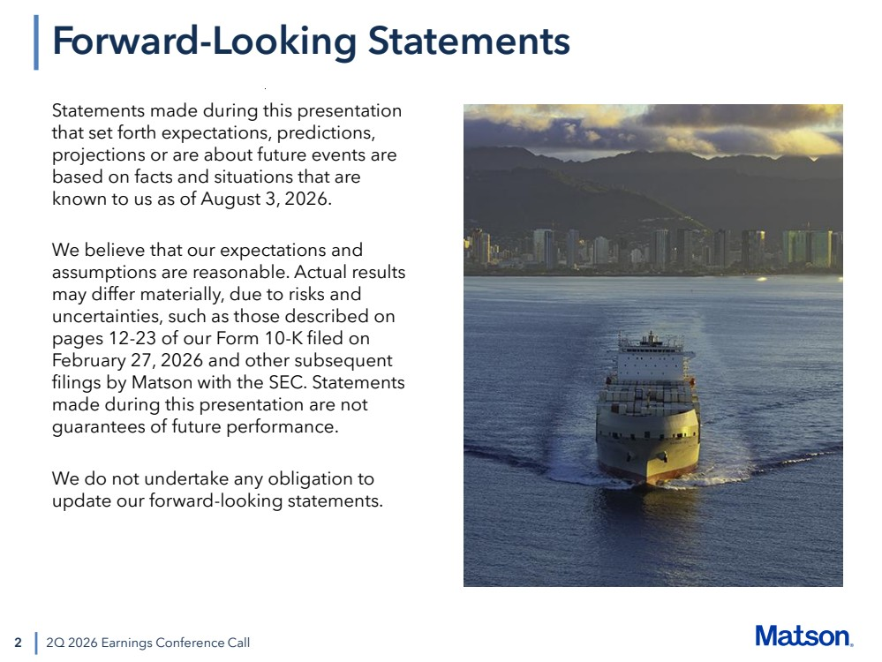 | 2 Statements made during this presentation that set forth expectations, predictions, projections or are about future events are based on facts and situations that are known to us as of August 3, 2026. We believe that our expectations and assumptions are reasonable. Actual results may differ materially, due to risks and uncertainties, such as those described on pages 12-23 of our Form 10-K filed on February 27, 2026 and other subsequent filings by Matson with the SEC. Statements made during this presentation are not guarantees of future performance. We do not undertake any obligation to update our forward-looking statements. 2Q 2026 Earnings Conference Call Forward-Looking Statements
 | 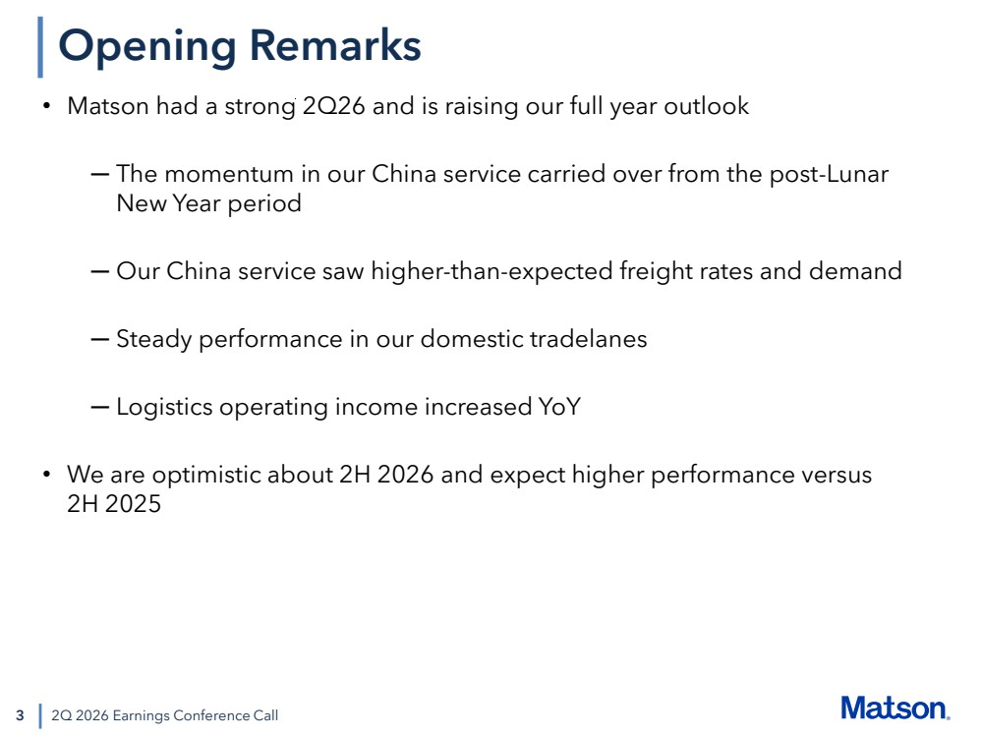 | 3 • Matson had a strong 2Q26 and is raising our full year outlook ─ The momentum in our China service carried over from the post-Lunar New Year period ─ Our China service saw higher-than-expected freight rates and demand ─ Steady performance in our domestic tradelanes ─ Logistics operating income increased YoY • We are optimistic about 2H 2026 and expect higher performance versus 2H 2025 2Q 2026 Earnings Conference Call Opening Remarks
 | 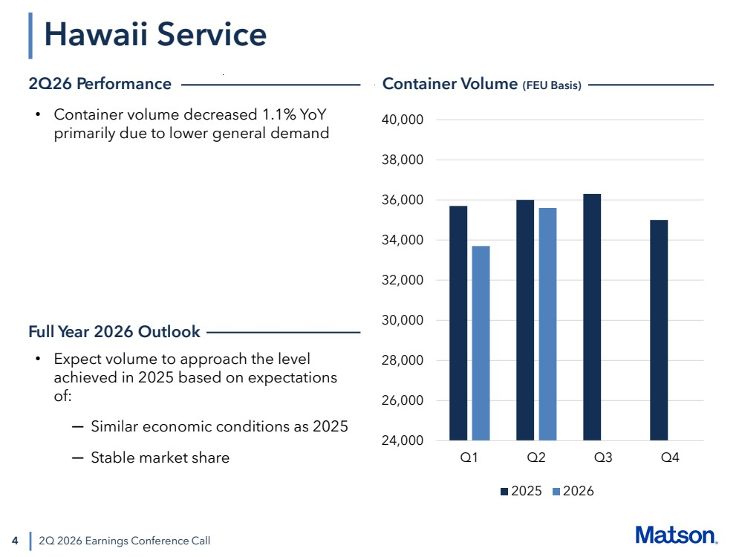 | 4 2Q 2026 Earnings Conference Call • Container volume decreased 1.1% YoY primarily due to lower general demand • Expect volume to approach the level achieved in 2025 based on expectations of: ─ Similar economic conditions as 2025 ─ Stable market share Hawaii Service 2Q26 Performance Container Volume (FEU Basis) Full Year 2026 Outlook 24,000 26,000 28,000 30,000 32,000 34,000 36,000 38,000 40,000 Q1 Q2 Q3 Q4 2025 2026
 | 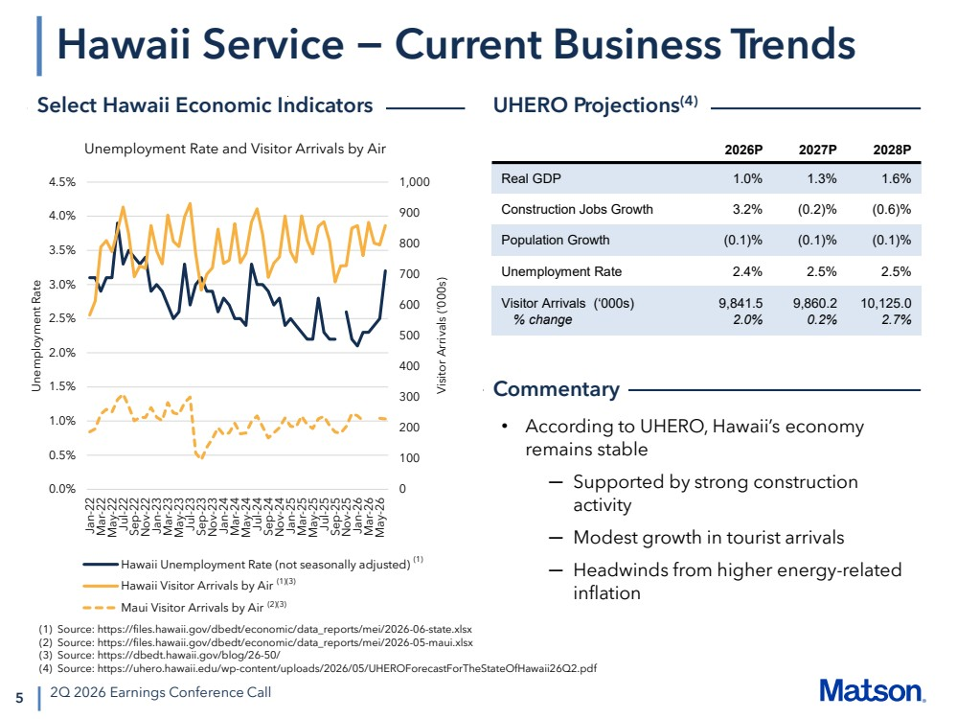 | 0 100 200 300 400 500 600 700 800 900 1,000 0.0% 0.5% 1.0% 1.5% 2.0% 2.5% 3.0% 3.5% 4.0% 4.5% Jan-22 Mar-22 May-22 Jul-22 Sep-22 Nov-22 Jan-23 Mar-23 May-23 Jul-23 Sep-23 Nov-23 Jan-24 Mar-24 May-24 Jul-24 Sep-24 Nov-24 Jan-25 Mar-25 May-25 Jul-25 Sep-25 Nov-25 Jan-26 Mar-26 May-26 Unemployment Rate Visitor Arrivals (‘000s) Unemployment Rate and Visitor Arrivals by Air Hawaii Unemployment Rate (not seasonally adjusted) Hawaii Visitor Arrivals by Air Maui Visitor Arrivals by Air 5 Hawaii Service − Current Business Trends 2Q 2026 Earnings Conference Call • According to UHERO, Hawaii’s economy remains stable ─ Supported by strong construction activity ─ Modest growth in tourist arrivals ─ Headwinds from higher energy-related inflation 2026P 2027P 2028P Real GDP 1.0% 1.3% 1.6% Construction Jobs Growth 3.2% (0.2)% (0.6)% Population Growth (0.1)% (0.1)% (0.1)% Unemployment Rate 2.4% 2.5% 2.5% Visitor Arrivals (‘000s) % change 9,841.5 2.0% 9,860.2 0.2% 10,125.0 2.7% Select Hawaii Economic Indicators UHERO Projections(4) Commentary (1) Source: https://files.hawaii.gov/dbedt/economic/data_reports/mei/2026-06-state.xlsx (2) Source: https://files.hawaii.gov/dbedt/economic/data_reports/mei/2026-05-maui.xlsx (3) Source: https://dbedt.hawaii.gov/blog/26-50/ (4) Source: https://uhero.hawaii.edu/wp-content/uploads/2026/05/UHEROForecastForTheStateOfHawaii26Q2.pdf (1) (1)(3) (2)(3)
 | 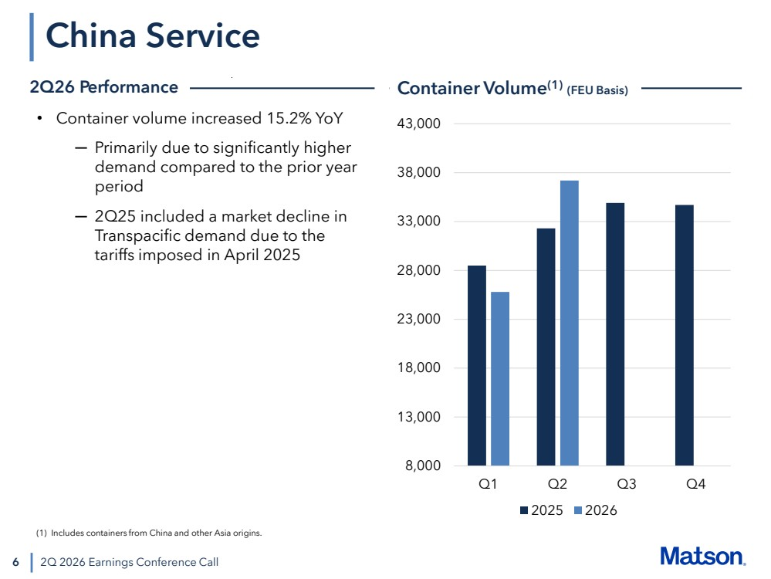 | 6 China Service 2Q 2026 Earnings Conference Call • Container volume increased 15.2% YoY ─ Primarily due to significantly higher demand compared to the prior year period ─ 2Q25 included a market decline in Transpacific demand due to the tariffs imposed in April 2025 2Q26 Performance Container Volume(1) (FEU Basis) (1) Includes containers from China and other Asia origins. 8,000 13,000 18,000 23,000 28,000 33,000 38,000 43,000 Q1 Q2 Q3 Q4 2025 2026
 | 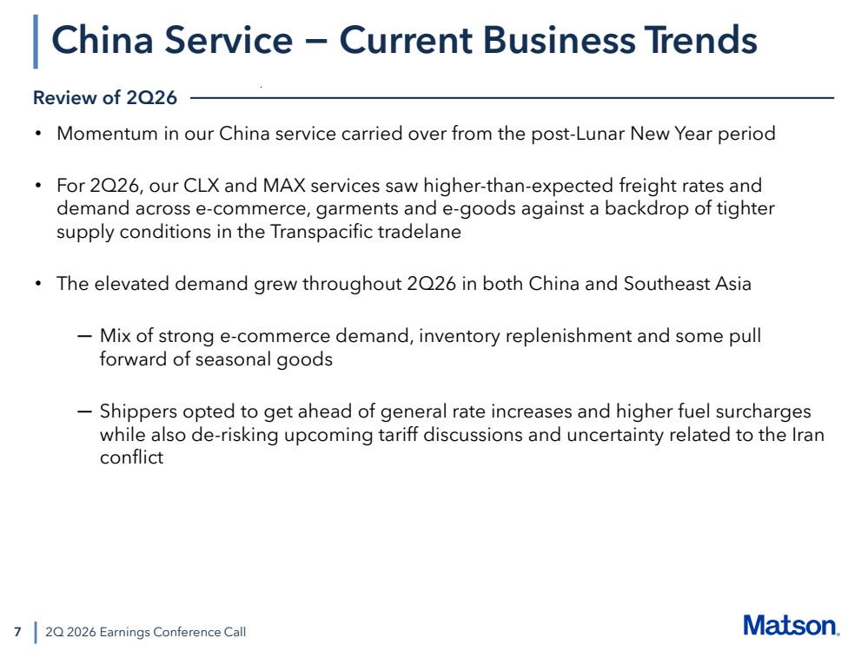 | 7 • Momentum in our China service carried over from the post-Lunar New Year period • For 2Q26, our CLX and MAX services saw higher-than-expected freight rates and demand across e-commerce, garments and e-goods against a backdrop of tighter supply conditions in the Transpacific tradelane • The elevated demand grew throughout 2Q26 in both China and Southeast Asia ─ Mix of strong e-commerce demand, inventory replenishment and some pull forward of seasonal goods ─ Shippers opted to get ahead of general rate increases and higher fuel surcharges while also de-risking upcoming tariff discussions and uncertainty related to the Iran conflict 2Q 2026 Earnings Conference Call China Service − Current Business Trends Review of 2Q26
 | 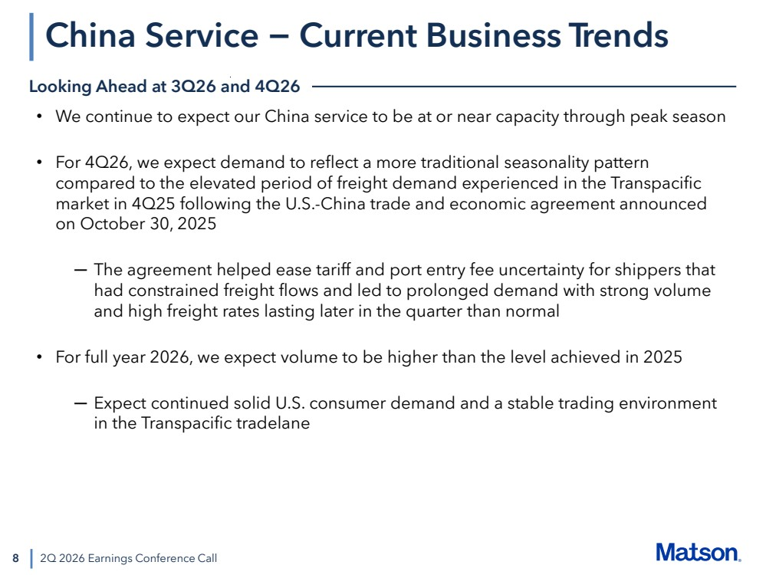 | 8 • We continue to expect our China service to be at or near capacity through peak season • For 4Q26, we expect demand to reflect a more traditional seasonality pattern compared to the elevated period of freight demand experienced in the Transpacific market in 4Q25 following the U.S.-China trade and economic agreement announced on October 30, 2025 ─ The agreement helped ease tariff and port entry fee uncertainty for shippers that had constrained freight flows and led to prolonged demand with strong volume and high freight rates lasting later in the quarter than normal • For full year 2026, we expect volume to be higher than the level achieved in 2025 ─ Expect continued solid U.S. consumer demand and a stable trading environment in the Transpacific tradelane 2Q 2026 Earnings Conference Call China Service − Current Business Trends Looking Ahead at 3Q26 and 4Q26
 | 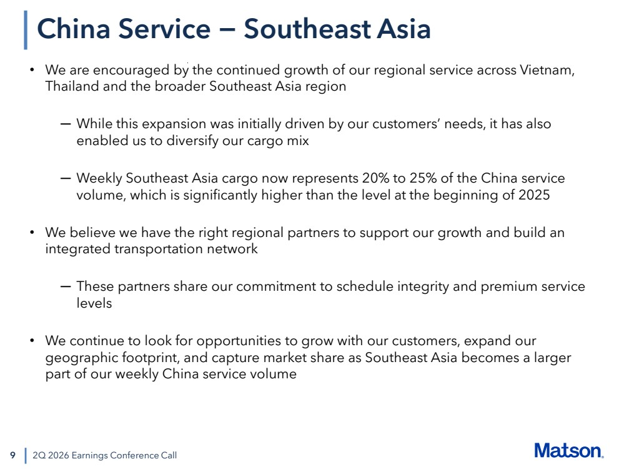 | 9 • We are encouraged by the continued growth of our regional service across Vietnam, Thailand and the broader Southeast Asia region ─ While this expansion was initially driven by our customers’ needs, it has also enabled us to diversify our cargo mix ─ Weekly Southeast Asia cargo now represents 20% to 25% of the China service volume, which is significantly higher than the level at the beginning of 2025 • We believe we have the right regional partners to support our growth and build an integrated transportation network ─ These partners share our commitment to schedule integrity and premium service levels • We continue to look for opportunities to grow with our customers, expand our geographic footprint, and capture market share as Southeast Asia becomes a larger part of our weekly China service volume 2Q 2026 Earnings Conference Call China Service − Southeast Asia
 | 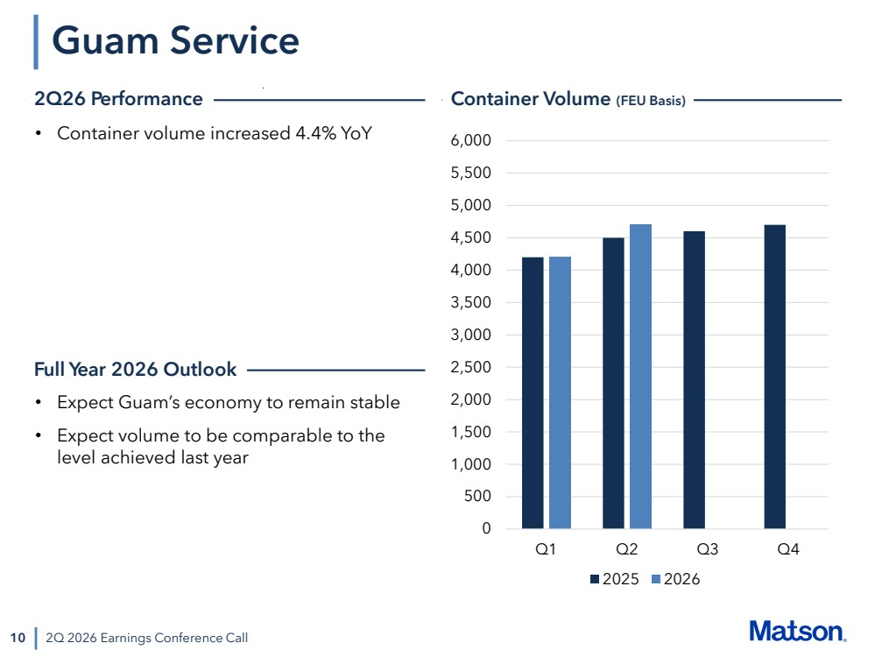 | 10 Guam Service 2Q 2026 Earnings Conference Call • Container volume increased 4.4% YoY • Expect Guam’s economy to remain stable • Expect volume to be comparable to the level achieved last year 2Q26 Performance Container Volume (FEU Basis) 0 500 1,000 1,500 2,000 2,500 3,000 3,500 4,000 4,500 5,000 5,500 6,000 Q1 Q2 Q3 Q4 2025 2026 Full Year 2026 Outlook
 | 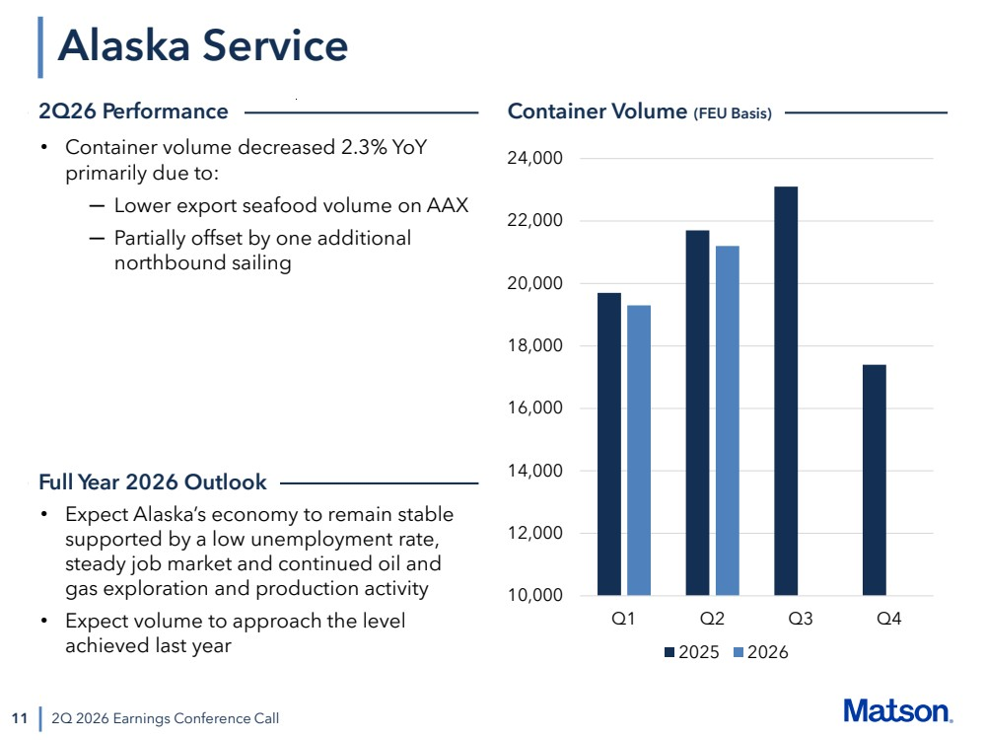 | 11 Alaska Service 2Q 2026 Earnings Conference Call • Container volume decreased 2.3% YoY primarily due to: ─ Lower export seafood volume on AAX ─ Partially offset by one additional northbound sailing 10,000 12,000 14,000 16,000 18,000 20,000 22,000 24,000 Q1 Q2 Q3 Q4 2025 2026 • Expect Alaska’s economy to remain stable supported by a low unemployment rate, steady job market and continued oil and gas exploration and production activity • Expect volume to approach the level achieved last year 2Q26 Performance Container Volume (FEU Basis) Full Year 2026 Outlook
 | 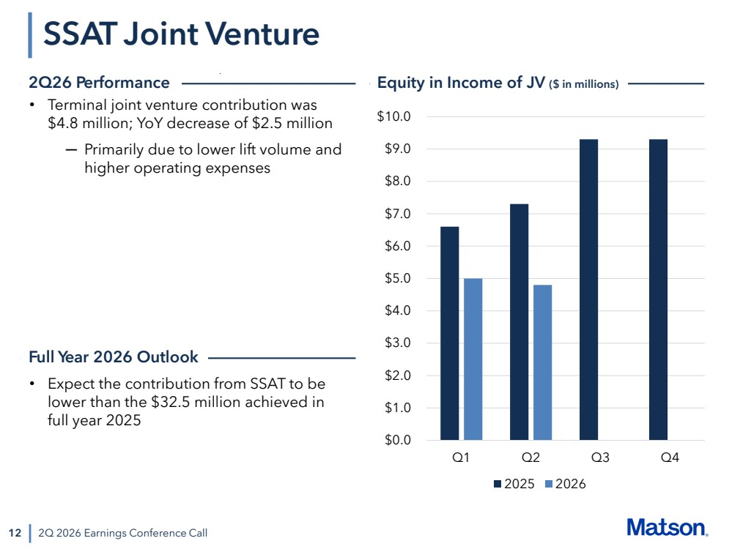 | 12 SSAT Joint Venture 2Q 2026 Earnings Conference Call • Terminal joint venture contribution was $4.8 million; YoY decrease of $2.5 million ─ Primarily due to lower lift volume and higher operating expenses $0.0 $1.0 $2.0 $3.0 $4.0 $5.0 $6.0 $7.0 $8.0 $9.0 $10.0 Q1 Q2 Q3 Q4 2025 2026 2Q26 Performance Equity in Income of JV ($ in millions) • Expect the contribution from SSAT to be lower than the $32.5 million achieved in full year 2025 Full Year 2026 Outlook
 | 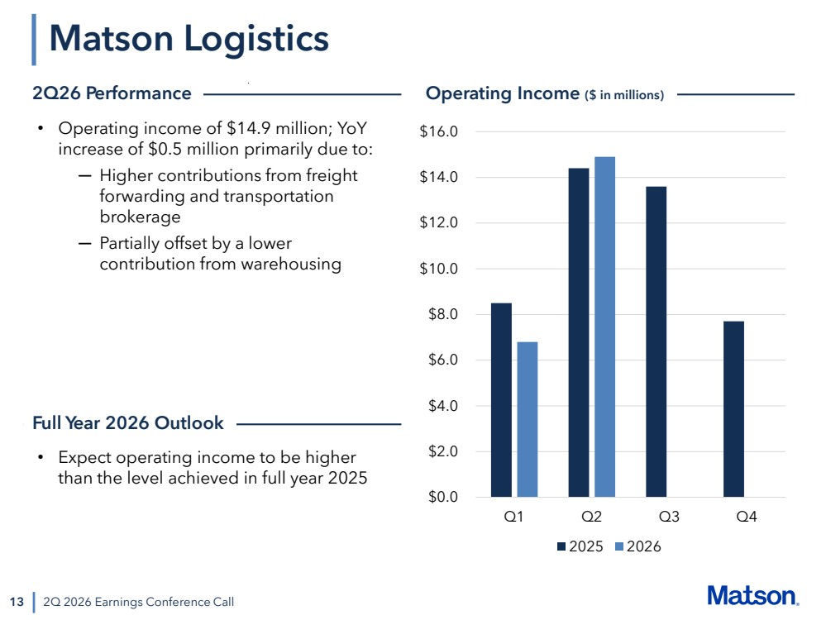 | 13 Matson Logistics 2Q 2026 Earnings Conference Call • Operating income of $14.9 million; YoY increase of $0.5 million primarily due to: ─ Higher contributions from freight forwarding and transportation brokerage ─ Partially offset by a lower contribution from warehousing $0.0 $2.0 $4.0 $6.0 $8.0 $10.0 $12.0 $14.0 $16.0 Q1 Q2 Q3 Q4 2025 2026 • Expect operating income to be higher than the level achieved in full year 2025 2Q26 Performance Operating Income ($ in millions) Full Year 2026 Outlook
 | 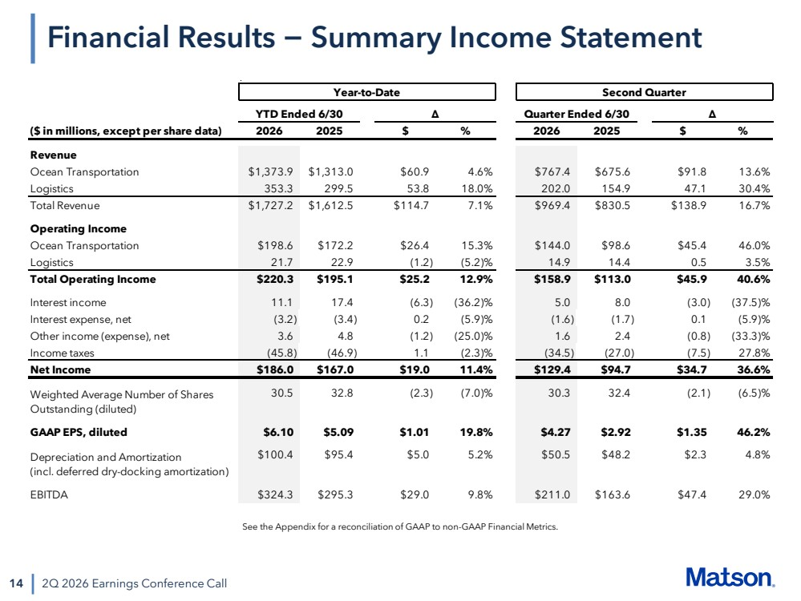 | 14 2Q 2026 Earnings Conference Call Financial Results − Summary Income Statement See the Appendix for a reconciliation of GAAP to non-GAAP Financial Metrics. Year-to-Date Second Quarter YTD Ended 6/30 Δ Quarter Ended 6/30 Δ ($ in millions, except per share data) 2026 2025 $ % 2026 2025 $ % Revenue Ocean Transportation $1,373.9 $1,313.0 $60.9 4.6% $767.4 $675.6 $91.8 13.6% Logistics 353.3 299.5 53.8 18.0% 202.0 154.9 47.1 30.4% Total Revenue $1,727.2 $1,612.5 $114.7 7.1% $969.4 $830.5 $138.9 16.7% Operating Income Ocean Transportation $198.6 $172.2 $26.4 15.3% $144.0 $98.6 $45.4 46.0% Logistics 21.7 22.9 (1.2) (5.2)% 14.9 14.4 0.5 3.5% Total Operating Income $220.3 $195.1 $25.2 12.9% $158.9 $113.0 $45.9 40.6% Interest income 11.1 17.4 (6.3) (36.2)% 5.0 8.0 (3.0) (37.5)% Interest expense, net (3.2) (3.4) 0.2 (5.9)% (1.6) (1.7) 0.1 (5.9)% Other income (expense), net 3.6 4.8 (1.2) (25.0)% 1.6 2.4 (0.8) (33.3)% Income taxes (45.8) (46.9) 1.1 (2.3)% (34.5) (27.0) (7.5) 27.8% Net Income $186.0 $167.0 $19.0 11.4% $129.4 $94.7 $34.7 36.6% 30.5 32.8 (2.3) (7.0)% 30.3 32.4 (2.1) (6.5)% GAAP EPS, diluted $6.10 $5.09 $1.01 19.8% $4.27 $2.92 $1.35 46.2% $100.4 $95.4 $5.0 5.2% $50.5 $48.2 $2.3 4.8% EBITDA $324.3 $295.3 $29.0 9.8% $211.0 $163.6 $47.4 29.0% Depreciation and Amortization (incl. deferred dry-docking amortization) Weighted Average Number of Shares Outstanding (diluted)
 | 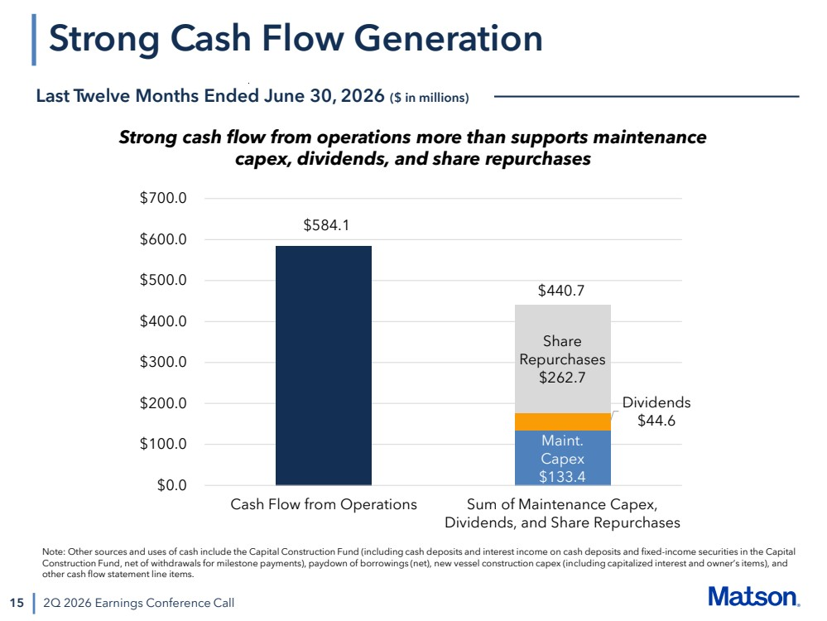 | 15 Strong Cash Flow Generation 2Q 2026 Earnings Conference Call Last Twelve Months Ended June 30, 2026 ($ in millions) $584.1 Maint. Capex $133.4 Dividends $44.6 Share Repurchases $262.7 $0.0 $100.0 $200.0 $300.0 $400.0 $500.0 $600.0 $700.0 Cash Flow from Operations Sum of Maintenance Capex, Dividends, and Share Repurchases $440.7 Strong cash flow from operations more than supports maintenance capex, dividends, and share repurchases Note: Other sources and uses of cash include the Capital Construction Fund (including cash deposits and interest income on cash deposits and fixed-income securities in the Capital Construction Fund, net of withdrawals for milestone payments), paydown of borrowings (net), new vessel construction capex (including capitalized interest and owner’s items), and other cash flow statement line items.
 | 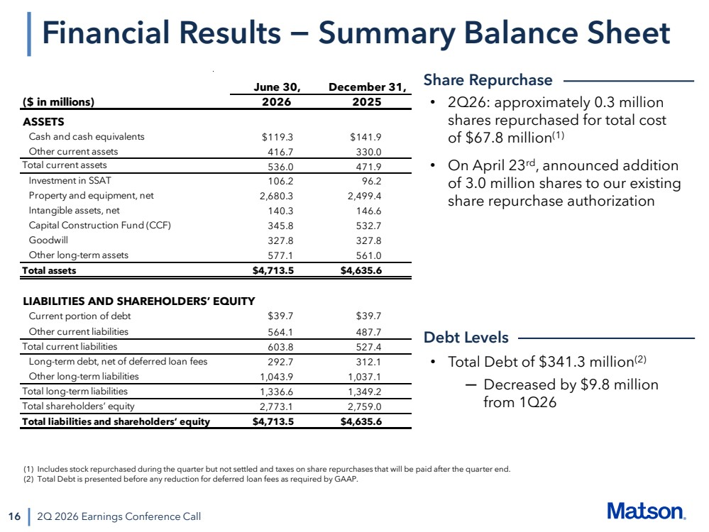 | 16 Financial Results − Summary Balance Sheet 2Q 2026 Earnings Conference Call • 2Q26: approximately 0.3 million shares repurchased for total cost of $67.8 million(1) • On April 23rd, announced addition of 3.0 million shares to our existing share repurchase authorization • Total Debt of $341.3 million(2) ─ Decreased by $9.8 million from 1Q26 Share Repurchase Debt Levels (1) Includes stock repurchased during the quarter but not settled and taxes on share repurchases that will be paid after the quarter end. (2) Total Debt is presented before any reduction for deferred loan fees as required by GAAP. ($ in millions) ASSETS Cash and cash equivalents $119.3 $141.9 Other current assets 416.7 330.0 Total current assets 536.0 471.9 Investment in SSAT 106.2 96.2 Property and equipment, net 2,680.3 2,499.4 Intangible assets, net 140.3 146.6 Capital Construction Fund (CCF) 345.8 532.7 Goodwill 327.8 327.8 Other long-term assets 577.1 561.0 Total assets $4,713.5 $4,635.6 LIABILITIES AND SHAREHOLDERS’ EQUITY Current portion of debt $39.7 $39.7 Other current liabilities 564.1 487.7 Total current liabilities 603.8 527.4 Long-term debt, net of deferred loan fees 292.7 312.1 Other long-term liabilities 1,043.9 1,037.1 Total long-term liabilities 1,336.6 1,349.2 Total shareholders’ equity 2,773.1 2,759.0 Total liabilities and shareholders’ equity $4,713.5 $4,635.6 June 30, December 31, 2026 2025
 | 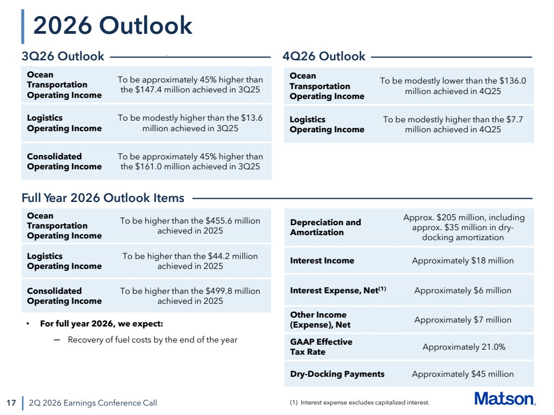 | • For full year 2026, we expect: ─ Recovery of fuel costs by the end of the year 17 2026 Outlook 2Q 2026 Earnings Conference Call 3Q26 Outlook Ocean Transportation Operating Income To be approximately 45% higher than the $147.4 million achieved in 3Q25 Logistics Operating Income To be modestly higher than the $13.6 million achieved in 3Q25 Consolidated Operating Income To be approximately 45% higher than the $161.0 million achieved in 3Q25 (1) Interest expense excludes capitalized interest. Full Year 2026 Outlook Items Depreciation and Amortization Approx. $205 million, including approx. $35 million in dry-docking amortization Interest Income Approximately $18 million Interest Expense, Net(1) Approximately $6 million Other Income (Expense), Net Approximately $7 million GAAP Effective Tax Rate Approximately 21.0% Dry-Docking Payments Approximately $45 million Ocean Transportation Operating Income To be higher than the $455.6 million achieved in 2025 Logistics Operating Income To be higher than the $44.2 million achieved in 2025 Consolidated Operating Income To be higher than the $499.8 million achieved in 2025 4Q26 Outlook Ocean Transportation Operating Income To be modestly lower than the $136.0 million achieved in 4Q25 Logistics Operating Income To be modestly higher than the $7.7 million achieved in 4Q25
 | 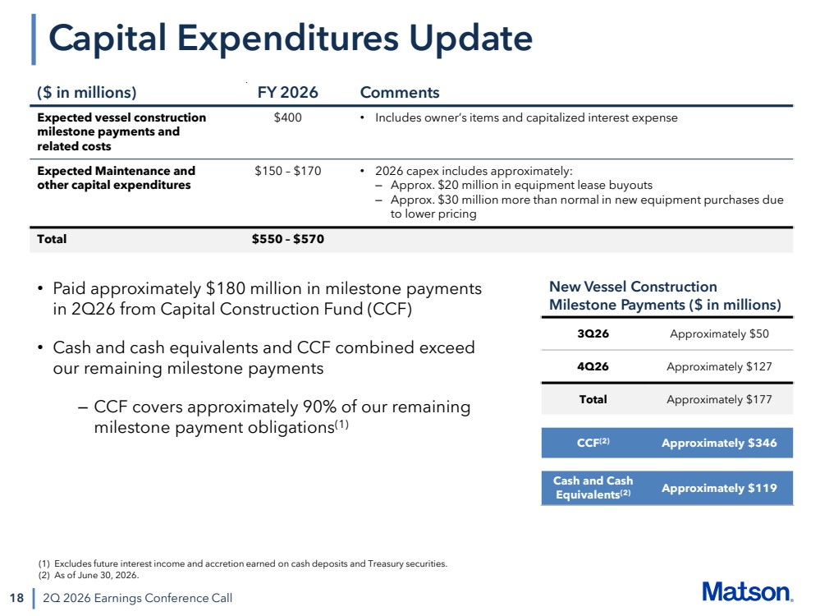 | 18 2Q 2026 Earnings Conference Call Capital Expenditures Update ($ in millions) FY 2026 Comments Expected vessel construction milestone payments and related costs $400 • Includes owner’s items and capitalized interest expense Expected Maintenance and other capital expenditures $150 – $170 • 2026 capex includes approximately: – Approx. $20 million in equipment lease buyouts – Approx. $30 million more than normal in new equipment purchases due to lower pricing Total $550 – $570 New Vessel Construction Milestone Payments ($ in millions) 3Q26 Approximately $50 4Q26 Approximately $127 Total Approximately $177 CCF(2) Approximately $346 Cash and Cash Equivalents(2) Approximately $119 • Paid approximately $180 million in milestone payments in 2Q26 from Capital Construction Fund (CCF) • Cash and cash equivalents and CCF combined exceed our remaining milestone payments – CCF covers approximately 90% of our remaining milestone payment obligations(1) (1) Excludes future interest income and accretion earned on cash deposits and Treasury securities. (2) As of June 30, 2026.
 | 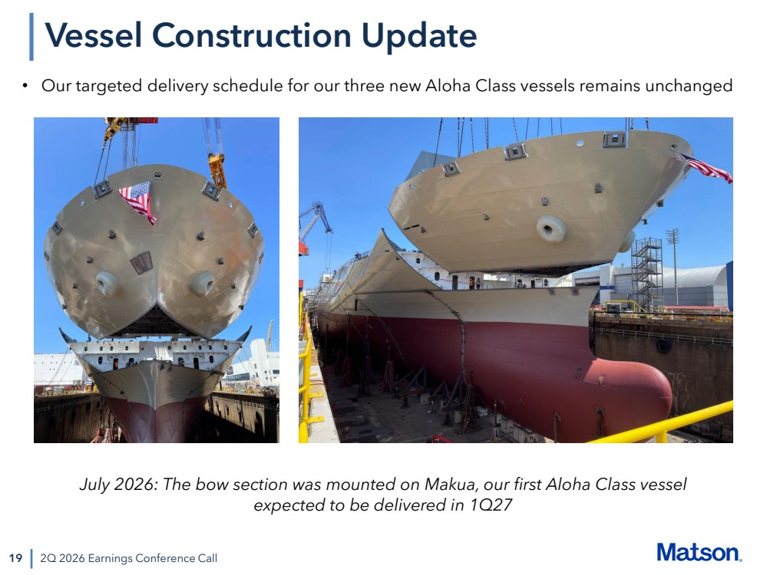 | 19 2Q 2026 Earnings Conference Call Vessel Construction Update • Our targeted delivery schedule for our three new Aloha Class vessels remains unchanged July 2026: The bow section was mounted on Makua, our first Aloha Class vessel expected to be delivered in 1Q27
 | 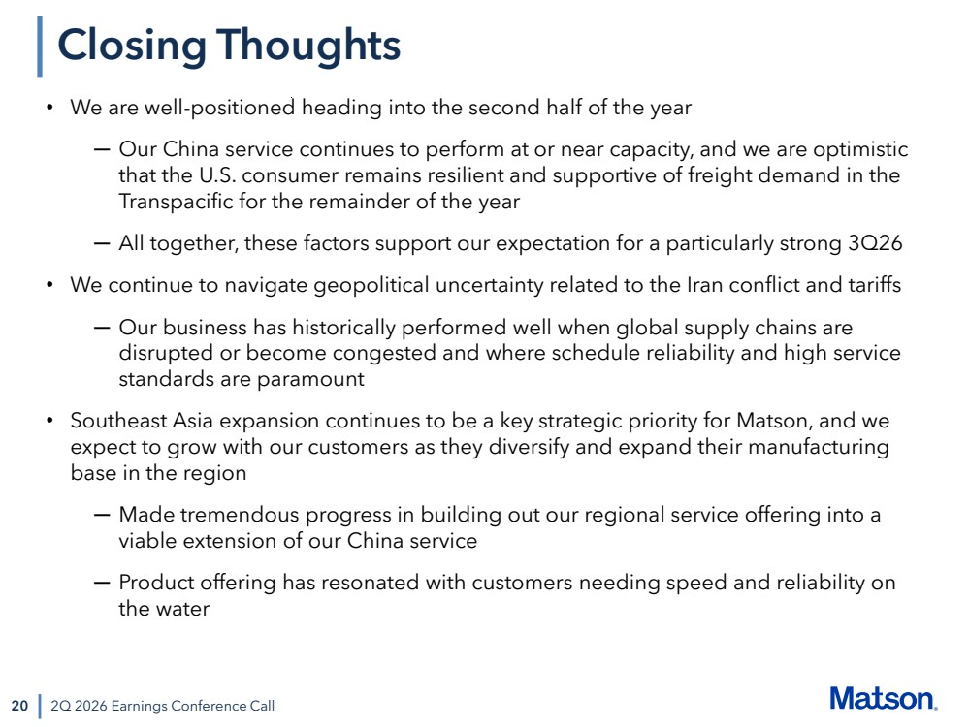 | 20 Closing Thoughts 2Q 2026 Earnings Conference Call • We are well-positioned heading into the second half of the year ─ Our China service continues to perform at or near capacity, and we are optimistic that the U.S. consumer remains resilient and supportive of freight demand in the Transpacific for the remainder of the year ─ All together, these factors support our expectation for a particularly strong 3Q26 • We continue to navigate geopolitical uncertainty related to the Iran conflict and tariffs ─ Our business has historically performed well when global supply chains are disrupted or become congested and where schedule reliability and high service standards are paramount • Southeast Asia expansion continues to be a key strategic priority for Matson, and we expect to grow with our customers as they diversify and expand their manufacturing base in the region ─ Made tremendous progress in building out our regional service offering into a viable extension of our China service ─ Product offering has resonated with customers needing speed and reliability on the water
 | 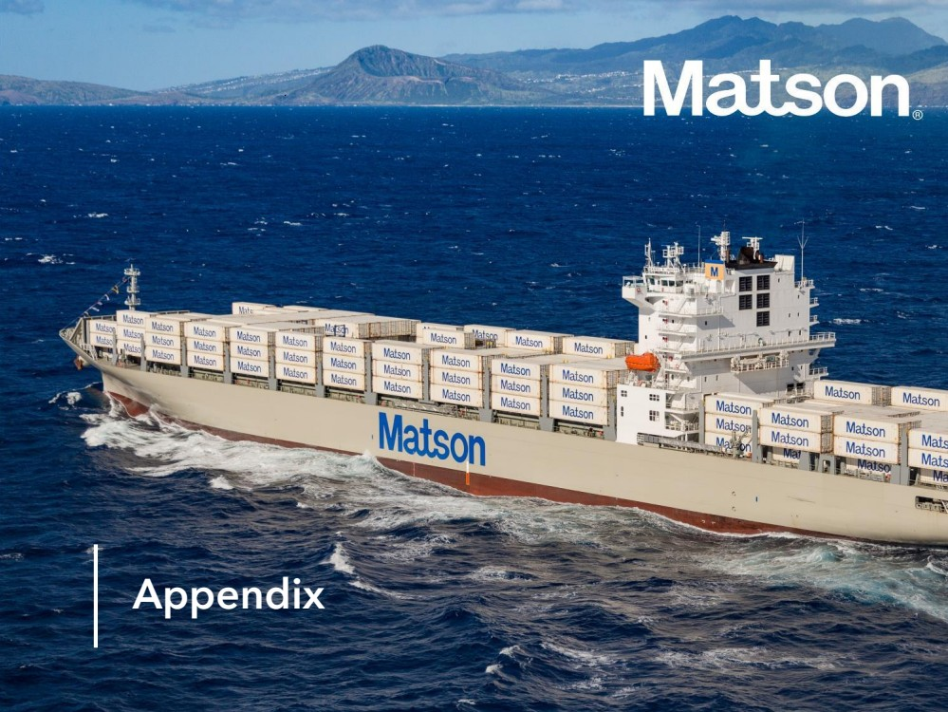 | Appendix
 | 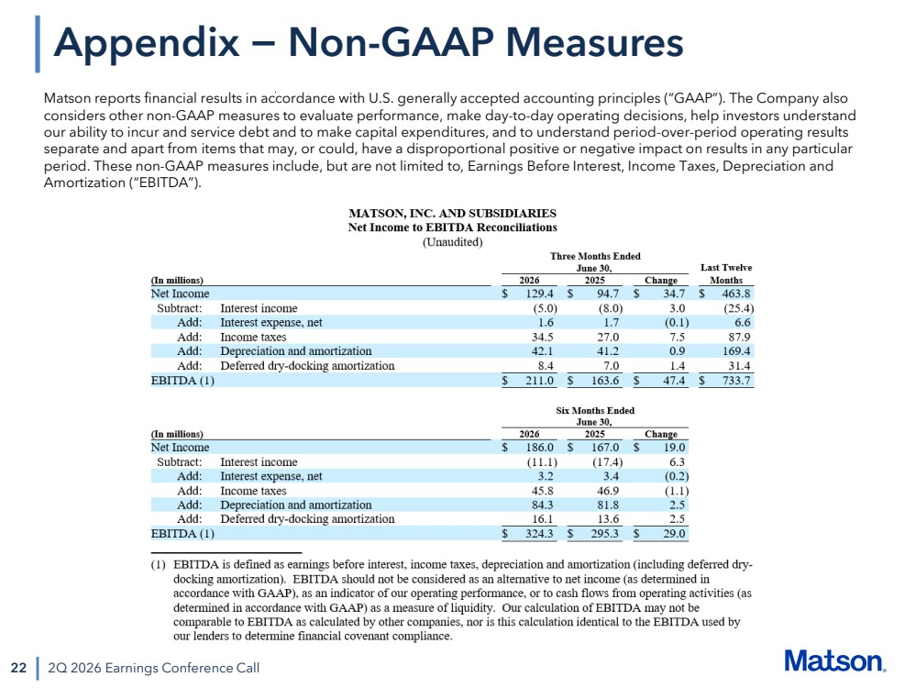 | 22 2Q 2026 Earnings Conference Call Appendix − Non-GAAP Measures Matson reports financial results in accordance with U.S. generally accepted accounting principles (“GAAP”). The Company also considers other non-GAAP measures to evaluate performance, make day-to-day operating decisions, help investors understand our ability to incur and service debt and to make capital expenditures, and to understand period-over-period operating results separate and apart from items that may, or could, have a disproportional positive or negative impact on results in any particular period. These non-GAAP measures include, but are not limited to, Earnings Before Interest, Income Taxes, Depreciation and Amortization (“EBITDA”).

