​
​
UNITED STATES
SECURITIES AND EXCHANGE COMMISSION
Washington, D. C. 20549
​
​
FORM 8-K
​
​
CURRENT REPORT
​
Pursuant to Section 13 or 15(d) of The Securities Exchange Act of 1934
​
Date of Report (Date of earliest event reported): July 15, 2026 (July 15, 2026)
​
Matson, Inc.
(Exact Name of Registrant as Specified in its Charter)
_____________________
​

Hawaii | ​ ​ | 001-34187 | ​ ​ | 99-0032630
(State or Other Jurisdiction of  Incorporation) | ​ | (Commission File Number) | ​ | (I.R.S. Employer Identification  No.)
​

 |  | ​
1411 Sand Island Parkway | ​ ​ | ​
Honolulu, Hawaii | ​ | 96819
(Address of principal executive offices) | ​ | (zip code)
​
Registrant’s telephone number, including area code: (808) 848-1211
(Former Name or former address, if changed since last report)
_____________________
​
Check the appropriate box below if the Form 8-K filing is intended to simultaneously satisfy the filing obligation of the registrant under any of the following provisions:
​
☐ | Written communications pursuant to Rule 425 under the Securities Act (17 CFR 230.425)
​
☐ | Soliciting material pursuant to Rule 14a-12 under the Exchange Act (17 CFR 240.14a-12)
​
☐ | Pre-commencement communications pursuant to Rule 14d-2(b) under the Exchange Act (17 CFR 240.14d-2(b))
​
☐ | Pre-commencement communications pursuant to Rule 13e-4(c) under the Exchange Act (17 CFR 240.13e-4(c))
​
Securities registered pursuant to Section 12(b) of the Act:
​

Title of each class | Trading Symbol(s) | Name of each exchange on which registered
Common Stock, without par value | MATX | New York Stock Exchange
​
Indicate by check mark whether the registrant is an emerging growth company as defined in Rule 405 of the Securities Act of 1933 (§230.405 of this chapter) or Rule 12b-2 of the Securities Exchange Act of 1934 (§240.12b-2 of this chapter).
Emerging growth company ☐
If an emerging growth company, indicate by check mark if the registrant has elected not to use the extended transition period for complying with any new or revised financial accounting standards provided pursuant to Section 13(a) of the Exchange Act. ☐
​
​
​
Item 2.02.Results of Operations and Financial Condition.
​
On July 15, 2026, Matson, Inc. (the “Company”) issued a press release announcing the Company’s preliminary earnings for the quarter ended June 30, 2026. A copy of the press release is attached hereto as Exhibit 99.1. In addition, the Company posted an investor presentation to its website. A copy of the investor presentation is attached hereto as Exhibit 99.2.
​
The information in this report (including Exhibits 99.1 and 99.2) is being furnished pursuant to Item 2.02 and shall not be deemed to be “filed” for purposes of Section 18 of the Securities Exchange Act of 1934, as amended.
​
​
Item 9.01.Financial Statements and Exhibits.
​
(a) - (c) Not applicable.
​
(d) Exhibits.
​
The exhibits listed below are being furnished with this Form 8-K.
​
99.1 | Press Release issued by Matson, Inc., dated July 15, 2026
​ | ​
99.2 | Investor Presentation, dated July 15, 2026
​ | ​
104 | Cover Page Interactive Data File (formatted in Inline XBRL and included as Exhibit 101).
​
​
​
​
SIGNATURE
​
Pursuant to the requirements of the Securities Exchange Act of 1934, as amended, the registrant has duly caused this report to be signed on its behalf by the undersigned hereunto duly authorized.
​
​
​
​ | ​
​ | MATSON, INC.
​ | ​
​ | ​
​ | /s/ Joel M. Wine
​ | Joel M. Wine
​ | Executive Vice President and Chief Financial Officer
​ | ​
​ | ​
Dated: July 15, 2026 | ​
​
​
​
​
​
Exhibit 99.1
​

​
​ | ​
Investor Relations inquiries: | News Media inquiries:
Justin Schoenberg | Keoni Wagner
Matson, Inc. | Matson, Inc.
510.628.4234 | 510.628.4534
jschoenberg@matson.com | kwagner@matson.com
​
FOR IMMEDIATE RELEASE
​
MATSON ANNOUNCES PRELIMINARY 2Q26 RESULTS, PROVIDES BUSINESS UPDATE AND ANNOUNCES 2Q26 EARNINGS CALL DATE
​
 | ● | Expects 2Q26 consolidated operating income to be $153.0 to $160.0 million
 | ● | Expects 2Q26 net income and diluted EPS to be $124.8 to $130.3 million and $4.12 to $4.30, respectively
 | ● | Year-over-year increase in consolidated operating income driven primarily by higher contribution from China service
 | ● | Repurchased approximately 0.3 million shares in 2Q26
 | ● | Announces second quarter earnings call date on August 3, 2026
​
HONOLULU, Hawaii (July 15, 2026) – Matson, Inc. (“Matson” or the “Company”) (NYSE: MATX) today announces preliminary second quarter financial results, provides a business update and announces that its second quarter earnings call will be held on August 3, 2026.
​
Matt Cox, Matson’s Chairman and Chief Executive Officer, commented, “Matson had a strong second quarter with momentum in our China service carrying over from the post-Lunar New Year period. Our CLX and MAX services saw higher-than-expected freight rates and demand across e-commerce, garments and e-goods against a backdrop of tighter supply conditions in the Transpacific tradelane. Looking ahead, we expect our China service to be at or near capacity through peak season, supported by current Transpacific market conditions and our expectation of continued solid U.S. consumer demand.”
​
Mr. Cox added, “In our domestic ocean tradelanes, we saw lower year-over-year volumes in Hawaii and Alaska and higher year-over-year volume in Guam. In Logistics, operating income increased year-over-year primarily due to higher contributions from freight forwarding and transportation brokerage, partially offset by a lower contribution from warehousing. As a result, for the second quarter 2026, we expect consolidated operating income to be $153.0 to $160.0 million. We also expect second quarter 2026 net income and diluted EPS to be $124.8 to $130.3 million and $4.12 to $4.30, respectively.”
​
​
1
​

Second Quarter Ocean Transportation Tradelane Volume (Forty-foot equivalent units (FEU)) (1)(2)(3):
​
For the three months ended June 30, 2026 compared to the three months ended June 30, 2025 and on a FEU basis:
 | ● | Hawaii container volume decreased 1.1 percent primarily due to lower general demand;
 | ● | Alaska container volume decreased 2.3 percent primarily due to lower export seafood volume on AAX, partially offset by one additional northbound sailing;
 | ● | China container volume increased 15.2 percent primarily due to significantly higher demand compared to the prior year period, which included a market decline in Transpacific demand due to the tariffs imposed in April 2025;
 | ● | Guam container volume increased 4.4 percent; and
 | ● | Other containers volume decreased 11.4 percent.
​

(1) | Approximate volume included for the period are based on the voyage departure date, but revenue and operating income are adjusted to reflect the percentage of revenue and operating income earned during the reporting period for voyages in transit at the end of each reporting period.
(2) | China volume includes containers from China and other Asia origins.
(3) | Other containers includes containers from services in various islands in Micronesia and the South Pacific, and Okinawa, Japan.
​
Other Items
​
 | ● | Liquidity and Debt: Matson’s cash and cash equivalents as of June 30, 2026 was approximately $119.3 million, which excluded $345.8 million in cash on deposit within the Capital Construction Fund (“CCF”). Total debt as of June 30, 2026 was $341.3 million.(4)
​
 | ● | Share Repurchases: During the second quarter of 2026, Matson repurchased approximately 0.3 million shares for a total cost of $67.8 million.(5) As of June 30, 2026, the Company had approximately 3.4 million shares remaining in its share repurchase program.
​
A slide presentation that accompanies this press release is available on the Company's website at www.matson.com, under Investors.
​
(4) | Total debt is presented before any reduction for deferred loan fees as required by GAAP.
(5) | Includes stock repurchased during the quarter but not settled and taxes on share repurchases that will be paid after the quarter end.
​
Teleconference and Webcast
​
A conference call is scheduled on August 3, 2026 at 4:30 p.m. ET when Matt Cox, Chairman and Chief Executive Officer, and Joel Wine, Executive Vice President and Chief Financial Officer, will discuss Matson’s second quarter results.
​ | ​
Date of Conference Call: | Monday, August 3, 2026
Scheduled Time: | 4:30 p.m. ET / 1:30 p.m. PT / 10:30 a.m. HT
​
The conference call will be broadcast live along with an additional slide presentation on the Company’s website at www.matson.com, under Investors.
​
Participants may register for the conference call at:
​
https://register-conf.media-server.com/register/BIb1df4ff4daa14ab9936f4360acc3071b
​
Registered participants will receive the conference call dial-in number and a unique PIN code to access the live event. While not required, it is recommended you join 10 minutes prior to the event starting time. A replay of the conference call will be available approximately two hours after the event by accessing the webcast link at www.matson.com, under Investors.
​
2
​

About the Company
​
Founded in 1882, Matson (NYSE: MATX) is a leading provider of ocean transportation and logistics services. Matson provides a vital lifeline of ocean freight transportation services to the domestic non-contiguous economies of Hawaii, Alaska, and Guam, and to other island economies in Micronesia. Matson also operates premium, expedited services from China to Long Beach, California, which includes cargo from other Asia origins, provides services to Okinawa, Japan and various islands in the South Pacific, and operates an international export service from Alaska to Asia. The Company's fleet of owned and chartered vessels includes containerships, combination container and roll-on/roll-off ships and barges. Matson Logistics, established in 1987, extends the geographic reach of Matson’s transportation network throughout North America and Asia. Its integrated logistics services include rail intermodal, highway brokerage, warehousing, freight consolidation, supply chain management, and freight forwarding to Alaska. Additional information about the Company is available at www.matson.com.
​
Forward-Looking Statements
​
Statements in this news release that are not historical facts are “forward-looking statements,” within the meaning of the Private Securities Litigation Reform Act of 1995, including without limitation those statements regarding capacity through peak season; Transpacific market conditions; U.S. consumer demand; and the timing, manner and volume of repurchases of common stock pursuant to the repurchase program. These statements involve a number of risks and uncertainties that could cause actual results to differ materially from those contemplated by the relevant forward-looking statement, including but not limited to risks and uncertainties relating to repeal, invalidation, substantial amendment or waiver of the Jones Act or changes in its application, or the Company were determined not to be a United States citizen under the Jones Act; changes in macroeconomic conditions, geopolitical developments, or governmental policies; our ability to offer a differentiated service in China for which customers are willing to pay a significant premium; new or increased competition; loss of or damage to key customer relationships; agreements with key vendors and third parties; fuel prices, our ability to collect fuel-related surcharges and/or the cost or limited availability of required fuels; evolving regulations and stakeholder expectations related to sustainability matters; timely or successful completion of fleet upgrade initiatives; performance under the Company’s vessel construction agreements with Hanwha Philly Shipyard; the occurrence of weather, natural disasters, maritime accidents, spill events and other physical and operating risks; transitional and other risks arising from climate change; actual or threatened health epidemics, outbreaks of disease, pandemics or other major health crises; significant operating agreements and leases that may not be renewed/replaced on favorable or acceptable terms; any unexpected dry-docking or repair costs; joint venture relationships; conducting business in foreign markets, including the imposition of tariffs or a change in international trade policies; modernization of terminals in Hawaii and Alaska; heightened security measures, war, actual or threatened terrorist attacks, efforts to combat terrorism and other acts of violence; consummating and integrating acquisitions; work stoppages or other labor disruptions caused by our unionized workers and other workers or their unions in related industries; loss of key personnel or failure to adequately manage human capital; the use of our information technology and communication systems; cybersecurity attacks; changes in our credit profile, disruptions of the credit markets or higher interest rates; our ability to access the debt capital markets; periodic revisions to the Company’s effective income tax rate; changes in the value of pension assets; exposure under multi-employer pension and post-retirement plans; continuation of the Title XI and CCF programs; costs to comply with and liability related to numerous safety, environmental, and other laws and regulations; and disputes, legal and other proceedings and government inquiries or investigations. These forward-looking statements are not guarantees of future performance. This release should be read in conjunction with our Annual Report on Form 10-K for the year ended December 31, 2025 and our other filings with the SEC through the date of this release, which identify important factors that could affect the forward-looking statements in this release. We do not undertake any obligation to update our forward-looking statements.
3
​

Exhibit 99.2
 | 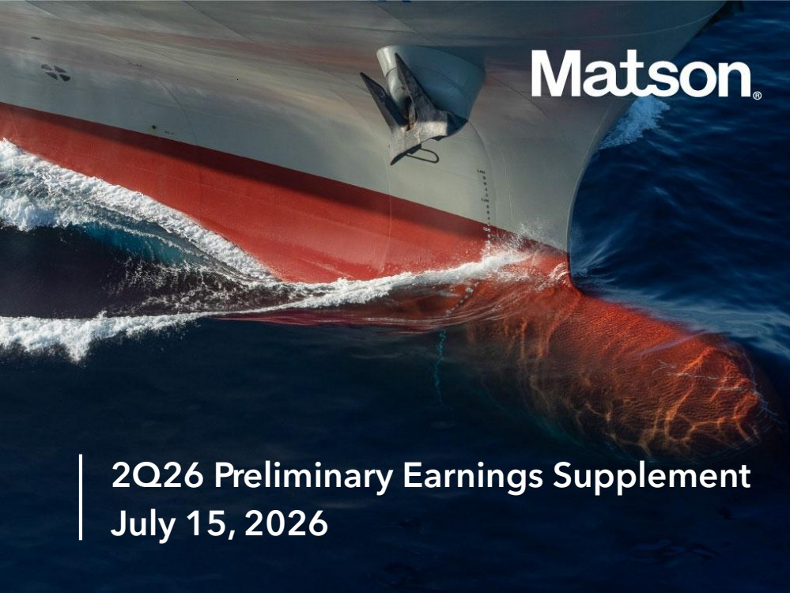 | 2Q26 Preliminary Earnings Supplement July 15, 2026
 | 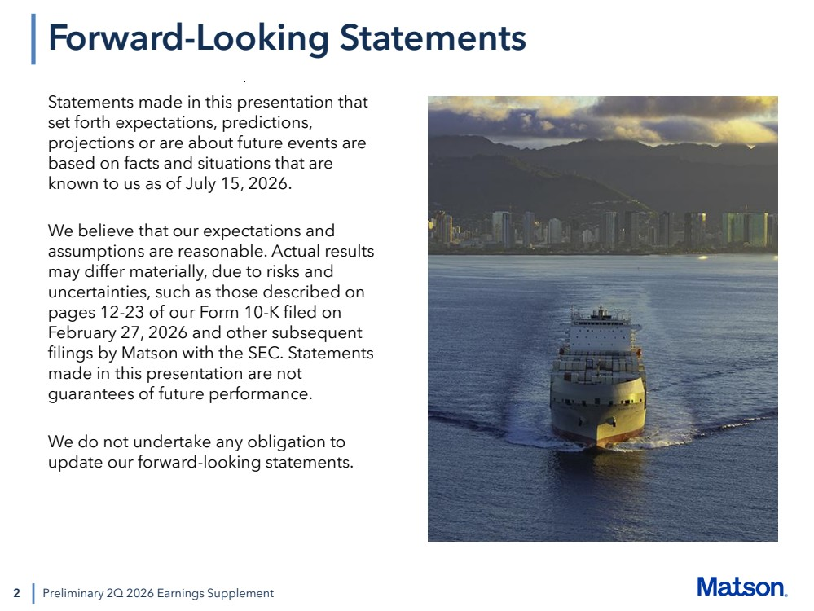 | 2 Statements made in this presentation that set forth expectations, predictions, projections or are about future events are based on facts and situations that are known to us as of July 15, 2026. We believe that our expectations and assumptions are reasonable. Actual results may differ materially, due to risks and uncertainties, such as those described on pages 12-23 of our Form 10-K filed on February 27, 2026 and other subsequent filings by Matson with the SEC. Statements made in this presentation are not guarantees of future performance. We do not undertake any obligation to update our forward-looking statements. Preliminary 2Q 2026 Earnings Supplement Forward-Looking Statements
 | 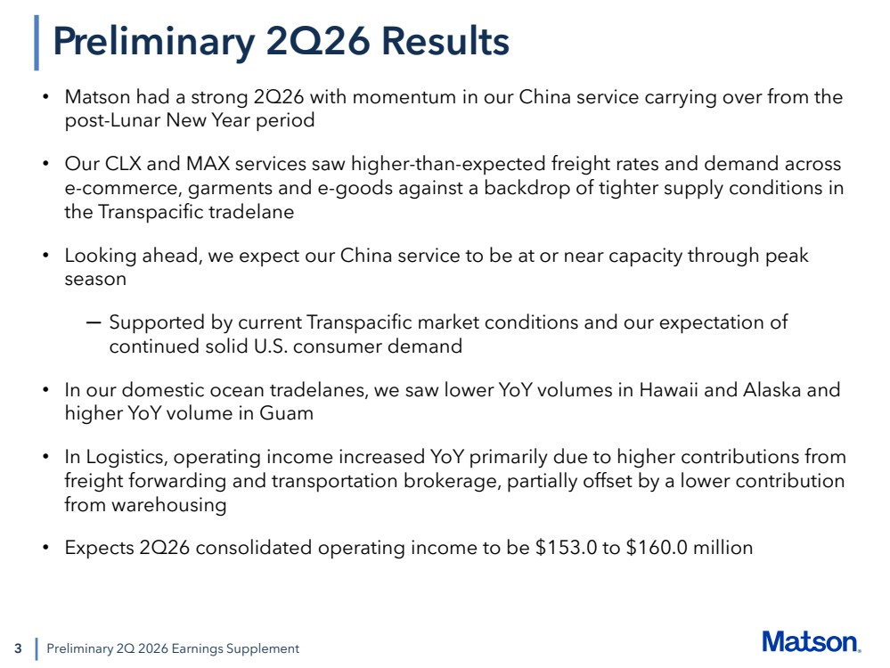 | 3 Preliminary 2Q 2026 Earnings Supplement Preliminary 2Q26 Results • Matson had a strong 2Q26 with momentum in our China service carrying over from the post-Lunar New Year period • Our CLX and MAX services saw higher-than-expected freight rates and demand across e-commerce, garments and e-goods against a backdrop of tighter supply conditions in the Transpacific tradelane • Looking ahead, we expect our China service to be at or near capacity through peak season ─ Supported by current Transpacific market conditions and our expectation of continued solid U.S. consumer demand • In our domestic ocean tradelanes, we saw lower YoY volumes in Hawaii and Alaska and higher YoY volume in Guam • In Logistics, operating income increased YoY primarily due to higher contributions from freight forwarding and transportation brokerage, partially offset by a lower contribution from warehousing • Expects 2Q26 consolidated operating income to be $153.0 to $160.0 million
 | 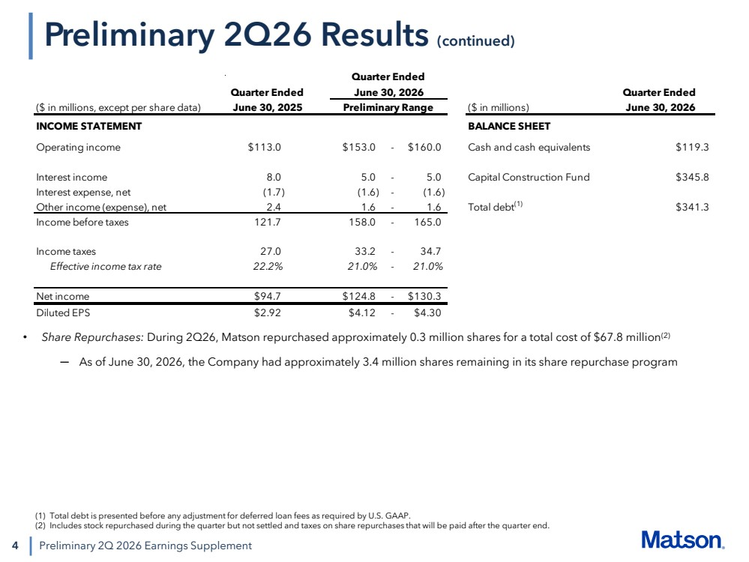 | 4 • Share Repurchases: During 2Q26, Matson repurchased approximately 0.3 million shares for a total cost of $67.8 million(2) ─ As of June 30, 2026, the Company had approximately 3.4 million shares remaining in its share repurchase program Preliminary 2Q 2026 Earnings Supplement Preliminary 2Q26 Results (continued) (1) Total debt is presented before any adjustment for deferred loan fees as required by U.S. GAAP. (2) Includes stock repurchased during the quarter but not settled and taxes on share repurchases that will be paid after the quarter end. June 30, 2026 Quarter Ended ($ in millions, except per share data) Preliminary Range ($ in millions) June 30, 2026 INCOME STATEMENT BALANCE SHEET Operating income $113.0 $153.0 - $160.0 Cash and cash equivalents $119.3 Interest income 8.0 5.0 - 5.0 Capital Construction Fund $345.8 Interest expense, net (1.7) (1.6) - (1.6) Other income (expense), net 2.4 1.6 - 1.6 Total debt(1) $341.3 Income before taxes 121.7 158.0 - 165.0 Income taxes 27.0 33.2 - 34.7 Effective income tax rate 22.2% 21.0% - 21.0% Net income $94.7 $124.8 - $130.3 Diluted EPS $2.92 $4.12 - $4.30 Quarter Ended June 30, 2025 Quarter Ended

